

**UNIVERSITY OF GREENWICH**  
COMP1682

Final Year Project

|  |  |
| --- | --- |
| Student name | Nguyen Duy Quang |
| ID number | 001353659 |
| Lecturer/Tutor name | Thai Minh Tuan |
| Student submission date | April 29th, 2024 |

**Undergraduate Final Year Project**

**Developing A Social Network Application for IT Experts**

**NGUYEN DUY QUANG**

**Table of Contents**

CHAPTER 1: INTRODUCTION 1

1. Overview 1

2. Purpose 2

3. Scope 2

4. Project Plan 2

CHAPTER 2: LITERATURE REVIEW 3

1. Cross-platform development vs native development 3

2. The impact of Social Media on Modern Society 4

3. Existing social networks aspects analysis 5

4. Programming language and Framework 6

4.1 Java 6

4.2 TypeScript 7

4.3 Dart 8

4.4 Spring Boot 9

4.5 Angular 11

4.6 Flutter 13

5. Database (Postgresql) 14

6. Other technologies 16

6.1 Bootstrap 16

6.2 Kafka 16

6.3 Keycloak 17

6.4 Digital Ocean 17

6.5 Cloudinary 17

6.6 Traefik 18

7. Conclusion 18

CHAPTER 3: DESIGIN 19

1. Database schema 19

2. Sitemap 31

3. Usecase diagram 32

3.1 User role 32

3.2 Admin role 33

4. Flow Chart 34

4.1 Register 34

4.2 Login 35

4.3 Reset password 35

4.4 Search friend 36

4.5 Update profile 37

4.6 Change password 37

4.7 Create new post 38

5. Mockup UI design 39

5.1 Register 39

5.2 Login 39

5.3 Home 40

5.4 Chat message 40

5.5 Friend 41

5.6 Notification 41

5.7 Profile 42

5.8 About user 43

5.9 Friend list 44

CHAPTER 4: METHODOLOGIES AND SOFTWARE DEVELOPMENT PROCESS 44

1. Software development process 44

2. Software development methodologies 45

3. Conclusion 46

CHAPTER 5: IMPLEMENTATION AND EXPLAINATION 47

1. Backend 47

1.1 Folder structure 47

1.2 Setup environtment 48

2. Frontend 51

2.1 Folder structure 51

2.2 Config proxy 52

2.3 Function and interface 53

3. Deploy Digital Ocean 72

3.1 Create droplet 72

3.2 Config environment 73

CHAPTER 6: TESTING AND EVALUATION 76

1. Testing 76

1.1 Functions 76

1.2 Performance 87

2. Evaluation 89

2.1 Self-evaluate 89

2.2 Survey from users 90

CHAPTER 7: CONCLUSIONS AND FUTUREWORK 97

1. Conlusion 97

2. Futurework 97

REFERENCES 98

APPENDIX 102

**List of Figures**

Figure 1. Gantt chart (1) 2

Figure 2. Gantt chart (2) 2

Figure 3. Database schema 19

Figure 4. Sitemap website 31

Figure 5. Use case of user role 32

Figure 6. Usecase of admin role 33

Figure 7. Register function 34

Figure 8. Login function 35

Figure 9. Reset password function 35

Figure 10. Search friend function 36

Figure 11. Update profile function 37

Figure 12. Change passwrod function 37

Figure 13. Create new post function 38

Figure 14. Register page 39

Figure 15. Login page 39

Figure 16. Home page 40

Figure 17. Chat message page 40

Figure 18. Add Friend page 41

Figure 19. Notification page 41

Figure 20. Profile page 42

Figure 21. About user page 43

Figure 22. Friend list page 44

Figure 23. Software development process model 45

Figure 24. Depicting the implementation in development life cycle 46

Figure 25. Backend’s folder structure 47

Figure 26. Frontend’s folder structure 51

Figure 27. Register page 53

Figure 28. Display error when sign up (1) 53

Figure 29. Enter do not enough field when siging up 53

Figure 30. Enter password and confirm password do not match 54

Figure 31. Display message when signing up successfully 54

Figure 32. Email verify account 54

Figure 33. Login page 55

Figure 34. User have to verify email before login 55

Figure 35. Incorrect credentials 55

Figure 36. Forgot password page 56

Figure 37. User does not exist in system 56

Figure 38. Check email to reset password 57

Figure 39. Email to reset password 57

Figure 40. Enter new password and confirm password 57

Figure 41. Home page 58

Figure 42. About user page 59

Figure 43. Update personal information 59

Figure 44. Enter all information when edit profile 60

Figure 45. Edit profile successfully 60

Figure 46. Manage experience 61

Figure 47. Add new work experience 62

Figure 48. A work was added 62

Figure 49. Add more work experience 62

Figure 50. Add new education 63

Figure 51. New education was added 63

Figure 52. Manage skills 64

Figure 53. Add new skill 64

Figure 54. New skills was added 65

Figure 55. Hover to change avatar 65

Figure 56. Choose new avatar 65

Figure 57. Choose new avatar and crop it 66

Figure 58. New avatar was saved 66

Figure 59. Hover to change cover 67

Figure 60. Choose new cover 67

Figure 61. Choose new cover and crop it 68

Figure 62. New cover was saved 68

Figure 63. View friend 69

Figure 64. Send friend request 69

Figure 65. Receive friend request 69

Figure 66. List friends of user 70

Figure 67. New conversation 70

Figure 68. Message from current user 71

Figure 69. Message from friend of user 71

Figure 70. Notification 72

Figure 71. Create droplet and assign domain 72

Figure 72. Access to the server by using SSH 73

Figure 73. .env file 73

Figure 74. Docker compose file (traefik) 73

Figure 75. Docker compose file (frontend and backend) 74

Figure 76. Docker compose file (database and pgadmin) 74

Figure 77. Docker compose file (keycloak and keycloak database) 75

Figure 78. Docker compose file (kafka) 75

Figure 79. Docker logs 76

Figure 80. Analysis all performance 87

Figure 81. Testing performance 87

Figure 82. Testing accessibility 88

Figure 83. Testing best practice 88

Figure 84. Testing SEO 89

Figure 85. Question 1 90

Figure 86. Question 2 91

Figure 87. Question 3 91

Figure 88. Question 4 92

Figure 89. Question 5 92

Figure 90. Question 6 93

Figure 91. Question 7 93

Figure 92. Question 8 94

Figure 93. Question 9 95

Figure 94. Question 10 96

**List of Tables**

Table 1. Comparing the Fundamental Characteristics of Various Types of Social Networks Described. 5

Table 2. Pros and Cons of Java 6

Table 3. Pros and Cons of TypeScript 7

Table 4. Pros and Cons of Dart 8

Table 5. Pros and Cons of Spring Boot 10

Table 6. Pros and Cons of Angular 11

Table 7. Pros and Cons of Flutter 13

Table 8. Pros and Cons of Postgresql 15

Table 9. User data desctiption 20

Table 10. User profile data desctiption 20

Table 11. User hobbies data description 21

Table 12. User experiences data desctiption 21

Table 13. User skills data desctiption 22

Table 14. User avatar data desctiption 22

Table 15. User cover desctiption 23

Table 16. Friend request data desctiption 23

Table 17. Friendship data desctiption 23

Table 18. Conversations data desctiption 24

Table 19. Participants data desctiption 24

Table 20. Message data description 25

Table 21. Message attachment data description 25

Table 22. Album data description 26

Table 23. Album media data description 26

Table 24. Posts data description 27

Table 25. Post media data description 27

Table 26. Post like data description 28

Table 27. Post comments data description 28

Table 28. Reply comments data description 29

Table 29. Like comments data description 29

Table 30. Notification data description 30

Table 31. User activities data description 30

Table 32. Test case 76

# INTRODUCTION

## Overview

Social network applications tailored to technology experts have gained prominence as the technology sector continues its rapid growth. This report explores the landscape of these specialized platforms, examining their motivations, challenges, and critical success factors. These networks are essential in connecting professionals, sharing knowledge, and staying updated in a rapidly evolving field (Smith, 2021).

The rise of social networks for technology experts is driven by the need to stay abreast of rapid technological changes. These networks offer a hub for knowledge exchange and best practices. Additionally, technology experts benefit from niche platforms that facilitate connections with peers who share similar skills and interests (Smith, 2021).

While the development of these networks is promising, it's not without challenges. Maintaining relevance in a fast-changing industry is critical. Data security and privacy are concerns due to the sensitive nature of the information shared. Attracting and retaining users requires a thoughtful strategy, balancing community building with professional networking (Brown, 2020).

Success in technology expert social networks relies on user engagement, achieved through features encouraging meaningful interactions and knowledge sharing. An effective content curation system, user-friendly interface, data security, and trust-building measures are vital. Fostering a sense of community where experts feel valued and heard is crucial for long-term success (Williams, 2019).

In conclusion, social network applications for technology experts are vital for professional development and networking in a dynamic industry. Overcoming challenges through user engagement, trust, and community building is key to success. As technology continues to evolve, these platforms remain essential for connecting, learning, and growing within the field (Johnson, 2018). The “Develop Social Network Applications for Technology Experts” initiative aspires to create a pivotal online domain wherein technology professionals can engage, collaborate, and remain apprised of advancements in their respective domains. The fulfillment of this vision is expected to make substantial contributions to technological progress and innovation. This report serves as a comprehensive guide to the project's goals, objectives, and the strategies devised for its execution.

## Purpose

The project aims to create a user-friendly and engaging online multiple platform that fosters connections, discussions, and opinion sharing among its users.

## Scope

Users have direct access to online posts within the system, where they can engage by liking or commenting. They can also connect with others, making friends and engaging in conversations.

## Project Plan

As seen in Figures 1 and 2, I have created a Gantt chart below using the time estimates and tasks.

* **Start day:** October 28th, 2023
* **Finish day:** May 15th, 2024

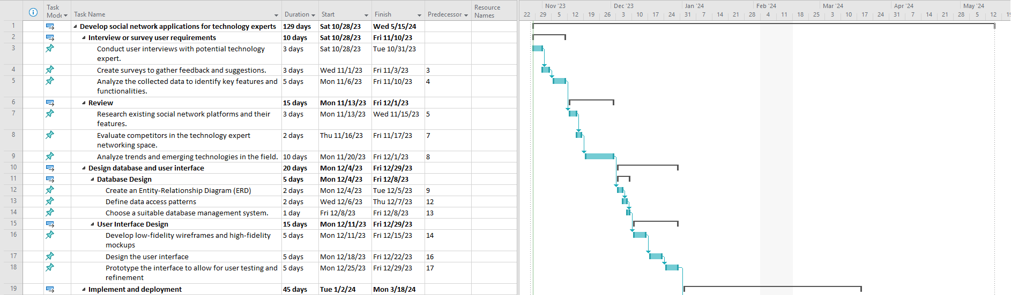

1. Gantt chart (1)

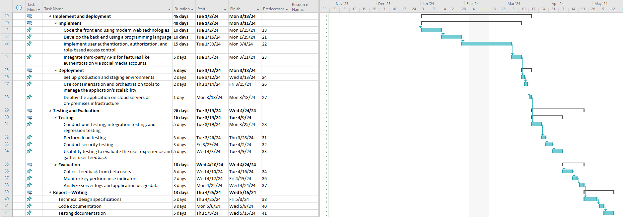

1. Gantt chart (2)

# LITERATURE REVIEW

## Cross-platform development vs native development

In today's online social landscape, numerous social networks have emerged, each thriving in its own way. Users often engage with multiple platforms simultaneously, acting as bridges between these networks (Zhang and Philip, 2018). This interconnectedness, termed aligned social networks, allows researchers and practitioners to analyze users' behaviors across platforms and study information propagation.

Understanding users' activities across multiple networks offers a comprehensive view, enabling personalized services. Moreover, it enhances our grasp of information dissemination, benefiting various applications. However, linking users' accounts across platforms remains a challenge, crucial for effective cross-platform services such as friend recommendations and information propagation analysis.

Native mobile applications (NMAs) are software programs tailored for a particular mobile platform like iOS or Android. These apps are built using platform-specific languages and tools, maximizing performance by directly accessing device capabilities such as cameras and GPS. Examples include Instagram for Android and Facebook for iOS, which leverage native development to offer seamless user experiences (Josh, 2024).

Native mobile applications offer several advantages, including improved performance due to optimized resource utilization and platform-specific frameworks. They also leverage unique device features, enhancing functionality for users. With a focus on specific platforms, native apps deliver a smoother user experience with fewer bugs and better interface integration. Additionally, native development simplifies the implementation of offline functionality, making it ideal for apps requiring offline capabilities. Furthermore, native tools often provide stronger security measures through platform-specific updates, ensuring better protection against vulnerabilities. Overall, native mobile app development stands out for its reliability and ability to deliver superior performance, user experience, offline functionality, and security (Josh, 2024).

In summary, the rise of interconnected social networks offers researchers valuable insights into user behavior and information dissemination. However, linking user accounts across platforms remains a challenge for effective cross-platform services. Meanwhile, native mobile applications excel in performance, user experience, offline functionality, and security, thanks to their platform-specific optimization. As we navigate this digital landscape, the integration of aligned social networks and the advancement of native apps promise to reshape our digital interactions significantly.

## The impact of Social Media on Modern Society

A social network, alongside its corresponding website, empowers users to craft profiles and establish authorized accounts, thereby creating digital representations of themselves. Users can select other members of the site as contacts, establish connections with them, and engage in various social activities. These platforms encompass personal details, group affiliations, friends lists, contact information, business connections, personal preferences, and historical data. In today's era of pervasive connectivity and technological advancement, individuals are seamlessly integrated into social networks through their mobile smartphones, whether at work, home, or elsewhere. This constant connection ensures users are promptly informed of new posts, messages, and current news, fostering a constructive environment where individuals stay abreast of the latest developments in technology and beyond.

Social networking sites like Facebook, MySpace, YouTube, and Bebo surged in popularity during the early 21st century, prompting questions about their longevity and user demographics. While concerns about privacy, inappropriate content, and excessive online time for youth arose, systematic research on these platforms was hindered by their commercial nature and proprietary data. However, studies on platforms like MySpace provided insights into user behavior and demographics. Despite privacy challenges, social network data holds promise for understanding social behavior and providing valuable insights, though it necessitates addressing security concerns. Recent advances propose data sanitation techniques to balance data utility with privacy protection. As social networks increasingly shape social interactions and information dissemination, understanding their structure and applications becomes crucial, with platforms like Sina Weibo and Tencent Wechat playing significant roles (Rath, 2022).

## Existing social networks aspects analysis

A social network comprises individuals, organizations, or other social entities interconnected through various relationships such as friendship, collaboration, or information exchange. Social network analysis delves into the examination of these relationship patterns among people, organizations, states, and similar entities, offering both visual and mathematical insights into human connections.

The Internet, particularly the Web, can be viewed as a vast social network. Within this framework, documents serve as nodes in the sociogram, while the links between them represent edges. Weblogs, a distinct subset of the Web, can also be seen as integral components of this social network (Jamali and Abolhassani, 2006).

Emerging concepts like the Semantic Web (SW) introduce the notion of structuring and interlinking data on the Web to make it usable for both humans and machines (Jamali and Abolhassani, 2006).

The Semantic Web and social network models complement each other, with Table 1 illustrating the fundamental properties of various types of social networks discussed herein and highlighting their differing formations (Jamali and Abolhassani, 2006).

1. Comparing the Fundamental Characteristics of Various Types of Social Networks Described.

|  |  |  |  |
| --- | --- | --- | --- |
| **Social Network Type** | **Actors** | **Ties** | **Direction** |
| Friendship Network | People in Society | Friendship relations between people | Undirected |
| Web's Social Network | Web Pages | Links Between Web Pages | Directed |
| Semantic Web Social Networks | Semantic Web Docs or Concepts in Them | Semantic Relations Between Documents or Concepts | Directed оr Undirected |

## Programming language and Framework

### Java

Java, a programming language and computing platform initially introduced by Sun Microsystems in 1995. It serves as a robust foundation for numerous services and applications, contributing substantially to the functioning of the modern world (java, 2024).

Renowned for its versatility, Java is a multi-platform, object-oriented, and network-centric language that also functions as a platform in its own right. Its attributes include speed, security, and reliability, making it a preferred choice for developing a wide array of software, ranging from mobile applications and enterprise solutions to big data applications and server-side technologies (amazon, 2024).

1. Pros and Cons of Java

|  |  |
| --- | --- |
| **Pros** | **Cons** |
| * **Easy-to-learn language:** Java stands out as an easy-to-learn language due to its simple syntax and high-level nature, catering to both novice and seasoned developers alike. * **Object-Oriented Programming (OOP):** The object-oriented programming (OOP) paradigm in Java offers unparalleled advantages in terms of code organization, maintenance, and scalability, making it a preferred choice for developers. * **Enhanced Security:** With its robust security features including encapsulation, inheritance, abstraction, and a built-in Security Manager, Java is highly regarded for developing secure applications. * **Platform Independence:** Java's platform independence is a cherished feature that allows developers to write code once and execute it on any platform with a Java Virtual Machine (JVM), making it an ideal choice for various projects such as web applications, mobile apps, cloud computing, and big data initiatives (Rafalski, 2023). | * **Performance Limitations:** While Java offers ease of development, its performance may sometimes lag behind native languages like C++ due to factors such as the overhead of its virtual machine and memory management. Challenges such as garbage collection, suboptimal caching configurations, and potential thread deadlocks can impact performance if not carefully addressed. * **Licensing Costs:** Businesses may find Java's licensing expenses, especially Oracle's commercial license terms, to be a potential financial burden. * **GUI Development Challenges:** Java's GUI development process can pose challenges due to inconsistencies and a lack of native aesthetics, which may require additional effort and resources to overcome (Rafalski, 2023). |

### TypeScript

TypeScript, an open-source programming language developed by Microsoft, enhances JavaScript by incorporating a robust type system. Widely utilized in conjunction with popular front-end frameworks like Angular, Vue, and React, TypeScript's versatility extends to backend development with Node.js, showcasing the adaptability of its type system (Zaitsev, 2023).

In its relationship with JavaScript, TypeScript offers all the features of the latter while introducing an additional layer: its sophisticated type system. Unlike JavaScript, TypeScript ensures type consistency, thereby enhancing code reliability (typescriptlang, 2024).

1. Pros and Cons of TypeScript

|  |  |
| --- | --- |
| **Pros** | **Cons** |
| * **Code Maintainability:** TypeScript promotes a structured coding approach with explicit type annotations, enhancing code self-documentation. * **Enhanced Developer Productivity**: TypeScript integrates seamlessly with IDEs and code editors, offering features like autocompletion, code navigation, and refactoring that significantly improve developer productivity. * **Improved Collaboration:** TypeScript facilitates better collaboration among developers, particularly in multi-member projects. * **Scalability:** TypeScript proves advantageous for large-scale projects, where the ability to define and enforce types becomes crucial as the codebase expands. * **Reduced Number of Bugs:** TypeScript's static type checking plays a vital role in identifying potential errors and bugs early in the development process (Zaitsev, 2023). | * **Additional Code:** TypeScript's adoption of static typing necessitates the inclusion of type annotations, potentially elongating development time, especially for smaller projects or during the initial development phases. * **Nuances of Use:** While TypeScript offers significant benefits, it can pose challenges, particularly in complex scenarios or when determining the correct types is ambiguous. In such instances, developers may opt to bypass type declarations to meet project deadlines or due to difficulties in finding suitable typing solutions. * **Adding Optional Technology:** Effective utilization of TypeScript within a project requires developers to possess a solid understanding of the language, ensuring optimal productivity and proficiency (Zaitsev, 2023). |

### Dart

Dart programming is a versatile language utilized in software application development. Renowned for its simplicity and clear syntax, Dart is easily grasped by developers of all levels. As an object-oriented language, Dart emphasizes the creation of reusable code components known as objects. Its applications span across web, mobile, and desktop platforms, making it a preferred choice for diverse software projects. Dart serves various purposes, including user interface construction, data handling, and server-side application development. (Badkar, 2023).

1. Pros and Cons of Dart

|  |  |
| --- | --- |
| **Pros** | **Cons** |
| * **Efficient Performance:** Dart stands out for its swift execution and efficiency, making it an ideal choice for applications demanding rapid response times and seamless performance. * **Ease of Learning:** With its straightforward syntax and intuitive structure, Dart facilitates an easy learning curve for developers. * **Flutter Integration:** Dart serves as the primary language for developing applications using the Flutter framework. * **Cross-Platform Development:** Dart empowers developers to create applications that run seamlessly across multiple platforms, including mobile (iOS and Android), web, and desktop. * **Strong Typing and Static Analysis**: Dart boasts a robust static type system and supports static analysis tools, facilitating early error detection and enhancing code reliability and maintainability throughout the development lifecycle (Badkar, 2023). | * **Limited Adoption:** Despite its growing popularity, Dart still trails behind other programming languages like JavaScript in terms of adoption and community size. * **Learning Curve for Existing Developers:** Developers accustomed to working with other languages may encounter a learning curve when transitioning to Dart, necessitating time investment to familiarize themselves with its syntax, features, and best practices. * **Flutter Dependency:** While Dart's tight integration with Flutter offers advantages for mobile app development, developers who prefer alternative frameworks or platforms may find themselves at a disadvantage (Badkar, 2023). |

### Spring Boot

Spring Boot, a highly acclaimed open-source framework, streamlines the development of Java applications for production environments with remarkable ease. Originating from Pivotal Software (now under VMware), Spring Boot simplifies Java application development by offering a comprehensive suite of conventions, templates, and an extensive library ecosystem. In this article, we delve into the benefits, drawbacks, and typical application scenarios associated with Spring Boot (Jayeshwarke, 2023).

1. Pros and Cons of Spring Boot

|  |  |
| --- | --- |
| **Pros** | **Cons** |
| * **Rapid Development:** Spring Boot empowers developers to focus on crafting business logic rather than being bogged down by boilerplate code and configuration. * **Microservices Friendly:** Spring Boot excels in constructing microservices-based architectures, facilitating the development of small, independent services that are easily deployable, scalable, and maintainable. * **Spring Ecosystem Integration:** Seamlessly integrating with various Spring projects such as Spring Data, Spring Security, and Spring Cloud, Spring Boot simplifies the creation of sophisticated applications requiring these components. * **Auto-Configuration:** Spring Boot streamlines application configuration by automatically configuring many aspects based on the libraries and dependencies included in your project. * **Embedded Servers:** With built-in support for embedded web servers like Tomcat, Jetty, and Undertow, Spring Boot eliminates the need for external server setup, enhancing development efficiency (Jayeshwarke, 2023). | * **Learning Curve:** While Spring Boot simplifies many aspects of application development, it can still be complex for beginners. * **Limited Flexibility:** Spring Boot’s auto-configuration and conventions may not align with your specific project requirements. * **Resource Overhead:** Spring Boot applications, particularly those using embedded servers, may consume more memory compared to traditional applications deployed on external servers (Jayeshwarke, 2023). |

### Angular

Angular, a robust development platform rooted in TypeScript, offers a component-based framework for crafting scalable web applications. It boasts an extensive array of seamlessly integrated libraries covering diverse functionalities such as routing, form management, and client-server communication. Additionally, Angular provides a comprehensive suite of developer tools facilitating the entire development lifecycle, from inception to deployment (angular, 2024).

1. Pros and Cons of Angular

|  |  |
| --- | --- |
| **Pros** | **Cons** |
| * Angular empowers Single Page Applications (SPAs), enabling users to seamlessly load new pages without server requests, enhancing dynamism and interactivity. * Angular boasts an extensive feature set: State management? Built-in. Reactivity? Built-in. Routing? Built-in. Dependency Injection (DI)? Built-in. Services? Built-in. * Angular facilitates cross-platform development: Progressive Web Apps (PWAs). Native mobile apps can be developed using strategies from Cordova, Ionic, or NativeScript. Moreover, Angular empowers desktop-installed apps across Mac, Windows, and Linux. * Angular intelligently optimizes templates into highly efficient code, tailored for today's JavaScript virtual machines, amalgamating the benefits of handcrafted code with the efficiency of a comprehensive framework. * Angular implements automatic code-splitting, ensuring that users only download the necessary code to render requested views, enhancing performance and reducing load times. * Angular adopts TypeScript, enhancing development with superior tooling, cleaner code, and scalability. * Angular fosters productivity by furnishing all necessary tools for scaffolding apps and components. The Angular CLI simplifies the generation of production-ready apps and components with a single command. * Angular's Model-View-Controller (MVC) architecture facilitates the separation of styles, logic, and markup, promoting maintainability and scalability. * Angular features a versatile templating system supporting both one-way and two-way binding, pipes, custom structural directives, and more, providing flexibility and extensibility. * Angular offers built-in support for Services and Dependency Injection (DI), enabling clear separation of business logic from components, resulting in cleaner and more modular code. * Angular incorporates a built-in animation API, facilitating the creation of high-performance, intricate animations and choreographies with minimal code (Siddharth, 2021). | * Angular, as a Single Page Application (SPA), traditionally faces challenges with SEO. However, leveraging Angular Universal allows for pre-rendering, significantly enhancing SEO capabilities. * While Angular does entail a steep learning curve, the investment pays off due to its robust capabilities and versatility. * Angular's complexity and verbosity make it less suited for smaller applications, as it's primarily designed to tackle complex systems and enterprise-level projects. * In developer surveys, Angular often receives mixed reviews. On platforms like The State of JavaScript, it garners significant negative opinions. Conversely, on the Stack Overflow developer survey, Angular ranks as the ninth most loved framework, trailing behind React and Vue. It also holds the eighth position as the most dreaded web framework but ranks third among the most desired frameworks (Siddharth, 2021). |

### Flutter

Flutter, Google's open-source platform, revolutionizes app development by enabling creation for mobile, desktop, and web platforms from a unified codebase. Unlike conventional solutions, Flutter transcends being merely a framework or library; it represents a comprehensive Software Development Kit (SDK).

An SDK encompasses a vast array of tools, including libraries, documentation, APIs, and occasionally frameworks, providing a complete suite for software development. Flutter epitomizes this concept by furnishing developers with all essential components needed to construct cross-platform applications seamlessly (altexsoft, 2022).

1. Pros and Cons of Flutter

|  |  |
| --- | --- |
| **Pros** | **Cons** |
| * **Single Codebase:** Flutter enables the creation of apps for multiple platforms from a single codebase, significantly reducing development time and effort. * **Rapid Development:** Flutter's hot reload feature accelerates the development process by instantly reflecting changes in the app. * **Performance:** Flutter apps boast exceptional speed and performance as they are compiled into native machine code. * **Rich UI Experience:** Leveraging Flutter's vast array of UI widgets, developers can craft visually stunning and engaging user interfaces. * **Native Feature Access:** Through Flutter's platform channels, developers can seamlessly access native features and APIs of underlying operating systems. * **Cross-Platform Development:** Being cross-platform, Flutter allows developers to create apps for iOS, Android, web, and desktop platforms using a unified codebase (Bhanderi, 2023). | * **Newness:** Flutter, compared to other frameworks, is relatively new in the market. Consequently, it may have a smaller talent pool and fewer resources, particularly in comparison to more mature ecosystems. * **App Size**: Due to including the Flutter engine and framework, initial download sizes of Flutter apps tend to be larger than native apps. * **Platform Specific Limitations:** While Flutter provides access to native capabilities, certain platform-specific features or APIs may not be fully supported or may require additional workarounds. * **Limited Libraries and Packages:** Despite the rapid expansion of the Flutter ecosystem, it may still offer fewer libraries and packages compared to more established frameworks. * **Dependency on Flutter Updates**: Flutter's continuous development may lead to occasional breaking changes between versions (Bhanderi, 2023). |

## Database (Postgresql)

PostgreSQL stands as an open-source object-relational database management system, distributed under the PostgreSQL License. It excels in supporting both relational (SQL) and non-relational (JSON) data models, offering a wide array of advanced SQL functionalities such as foreign keys, subqueries, and triggers.

Highly extensible, PostgreSQL enables the definition of custom data types and the creation of bespoke functions. Its robust feature set encompasses key extensions like point-in-time recovery, fine-grained access controls, multi-version concurrency control (MVCC), and tablespaces. Additionally, being open source, it enjoys compatibility with major operating systems including Linux, Microsoft Windows, macOS, and Unix (cloud, 2024).

1. Pros and Cons of Postgresql

|  |  |
| --- | --- |
| **Pros** | **Cons** |
| * PostgreSQL stands out as a reliable option for running dynamic websites and web applications, often integrated as part of the popular LAMP stack. * Its robust write-ahead logging feature enhances fault tolerance, ensuring data integrity even in the face of unexpected failures. * With its open source nature, PostgreSQL's freely available source code provides users with the flexibility to customize and adapt it to suit their specific business requirements. * Support for geographic objects makes PostgreSQL an ideal choice for implementing location-based services and Geographic Information Systems (GIS), offering capabilities for managing geospatial data effectively. * Learning PostgreSQL is straightforward, as it boasts an intuitive interface and user-friendly features, minimizing the need for extensive training. * PostgreSQL's low maintenance requirements make it suitable for both embedded and enterprise applications, offering hassle-free administration for various use cases (Peterson, 2024). | * PostgreSQL, being community-driven and lacking ownership by a single organization, has faced challenges in raising its profile despite its comprehensive feature set, which rivals other Database Management Systems (DBMS). * Efforts to enhance speed often necessitate more extensive modifications in PostgreSQL compared to MySQL, primarily due to PostgreSQL's emphasis on maintaining compatibility. * While many open-source applications support MySQL, there may be instances where support for PostgreSQL is lacking or less widespread. * In performance comparisons, PostgreSQL tends to exhibit slower speeds than MySQL in certain metrics (Peterson, 2024). |

## Other technologies

### Bootstrap

Bootstrap, a freely available open-source front-end development framework, facilitates the creation of websites and web applications. Its primary focus is on enabling responsive development, particularly emphasizing mobile-first approaches.

With a comprehensive collection of syntax and components, Bootstrap streamlines the process of designing templates for websites. By leveraging a pre-defined grid system, developers can easily incorporate responsive design principles into their projects.

Utilizing a combination of HTML, CSS, and JavaScript, Bootstrap provides a robust foundation for building modern web experiences. By abstracting away the complexities of basic commands and functions, Bootstrap empowers developers to accelerate website development without sacrificing quality or responsiveness (Zola, 2022).

### Kafka

Apache Kafka serves as a distributed data store tailored for efficiently ingesting and processing streaming data in real-time. Streaming data, originating from myriad sources, entails continuous generation and simultaneous transmission of data records.

Kafka caters to its users with three core functionalities:

* Facilitating the publication and subscription to streams of records.
* Efficiently storing streams of records in the sequential order of generation.
* Enabling real-time processing of streams of records.

Primarily utilized for constructing real-time streaming data pipelines, Kafka empowers the development of applications capable of seamlessly adapting to dynamic data streams. By seamlessly integrating messaging, storage, and stream processing capabilities, Kafka facilitates the storage and analysis of both historical and real-time data (amazon, 2024).

### Keycloak

Keycloak, an open-source identity and access management tool developed by Red Hat, serves as a comprehensive solution for securing web applications and RESTful web services with single sign-on capabilities. Red Hat's blog defines Keycloak as a robust single sign-on solution designed to simplify the task of securing applications and services for developers.

With Keycloak, developers can effortlessly secure their applications and services while enjoying features such as user authentication and secure invocation of REST APIs and microservices with minimal coding required. Moreover, Keycloak offers the flexibility to integrate users from various sources and social networks, including Google, GitHub, Facebook, and Twitter, streamlining user management across platforms (Bayoglu, 2023).

### Digital Ocean

DigitalOcean, an Infrastructure as a Service (IaaS) provider, has recently expanded its offerings to include an Application Platform as a Service (PaaS) option. Unlike traditional PaaS providers like Google App Engine or Heroku, DigitalOcean gives users direct access to the underlying virtual machines supporting their applications. This means users have full control over disk space, memory allocation, networking configurations, operating systems, and more, allowing them to tailor their environment to suit their application's specific requirements (papertrail, 2024).

While DigitalOcean offers a range of services, its primary focus is on application and website hosting. To deploy applications on DigitalOcean's IaaS environment, developers launch what the company refers to as "droplets" - private virtual machine instances. These droplets are similar to instances on Amazon Elastic Compute Cloud (EC2) or Azure, with the distinction that DigitalOcean does not support Microsoft Windows instances (Gillis, 2022).

### Cloudinary

Cloudinary, a leading Software-as-a-Service (SaaS) solution, specializes in efficiently managing media assets stored in the cloud. Whether it's images or videos for web or mobile applications, Cloudinary provides a comprehensive suite of services. These include upload management, administration, optimized delivery, storage, and manipulation—all seamlessly executed on Cloudinary's scalable servers, dynamically accommodating sudden spikes in traffic and high loads.

At the heart of Cloudinary's offering is its robust Digital Media Management (DAM) platform. Its intuitive user interface caters to both creative designers and developers, facilitating smooth collaboration. Additionally, Cloudinary boasts a powerful API, enabling easy integration of user-generated and in-house media content into mobile apps or websites with minimal code requirements (javatpoint, 2021).

### Traefik

Traefik, also known as Træfik, is a dynamic and adaptable reverse proxy and load balancer tailored for modern, distributed, and microservices architectures. Serving as a critical component of server infrastructure, Traefik effectively oversees and optimizes network traffic, ensuring streamlined routing and bolstering the performance and security of web services.

Designed for contemporary distributed setups, Traefik shines in environments where services experience frequent scaling fluctuations. With its dynamic configuration capabilities, support for multiple backends, automatic SSL/TLS, and rich customization features, Traefik streamlines web server management, boosts performance, fortifies security, and furnishes actionable insights for application monitoring and issue resolution.

In a competitive landscape alongside NGINX and HAProxy, Traefik's distinct advantages in dynamic and cloud-native settings set it apart. Installation and setup on platforms like CentOS and Ubuntu yield a potent solution for efficiently handling network traffic (Nek, 2024).

## Conclusion

In my exploration of various programming languages and technologies, I've delved into their unique strengths and weaknesses. As I proceed, my aim is to carefully analyze the guidelines and documentation provided for each technology, ensuring I make informed decisions when applying them to my project. Recognizing that each technology offers distinct advantages and drawbacks, my approach involves skillfully combining them to achieve optimal results. By leveraging the strengths of each technology while mitigating their respective limitations, I endeavor to craft a solution that delivers the utmost efficiency and effectiveness for my project.

# DESIGIN

## Database schema

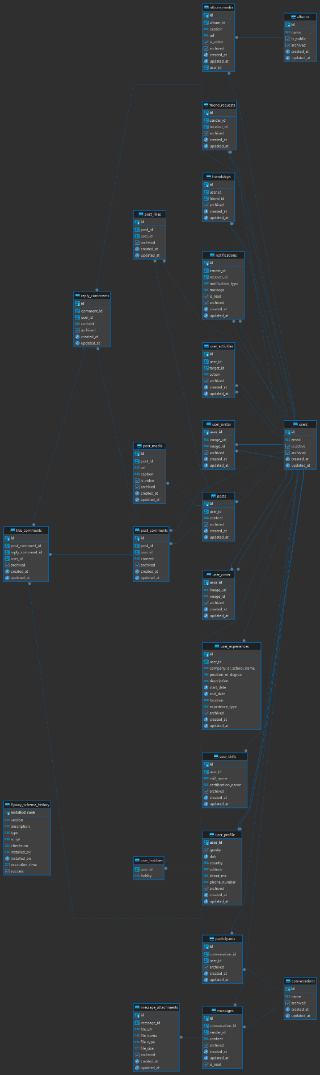

1. Database schema

Below is a description of the database. Since all tables have "archive", “create_at”, “updated_at”, I will not add a description to each table. Archive is used to hide data when users delete it. Created_at and Updated_at are used to store the date and time when a row was created or updated.

1. User data desctiption

Because I use keycloak to perform authentication functions as well as permissions, full name, password, and role will all be saved on keycloak.

Stores essential information for user accounts.

|  |  |  |
| --- | --- | --- |
| **Field name** | **Data type** | **Description** |
| id | uuid | Unique identifier for each user, stored as a UUID for universal uniqueness. |
| email | varchar(255) | Email address of the user, stored as VARCHAR(255) for compatibility and identification. |
| is_active | bool | Indicates if the user account is active. |

1. User profile data desctiption

Contains extended profile information for each user.

|  |  |  |
| --- | --- | --- |
| **Field name** | **Data type** | **Description** |
| user_id | uuid | Unique identifier for each user, referencing the id column in the users table. |
| gender | bool | Indicates the gender of the user. |
| dob | date | Date of birth of the user. |
| country | varchar(255) | Country where the user resides. |
| address | varchar(255) | Physical address of the user. |
| about_me | text | Description or bio of the user |
| phone_number | varchar(255) | Contact phone number of the user |

1. User hobbies data description

Store hobbies of user

|  |  |  |
| --- | --- | --- |
| **Field name** | **Data type** | **Description** |
| user_id | uuid | Unique identifier for each user, referencing the id column in the users table. |
| hobby | varchar(255) | hobby or interest of the user |

1. User experiences data desctiption

Logs the work and educational experiences of users.

|  |  |  |
| --- | --- | --- |
| **Field name** | **Data type** | **Description** |
| id | uuid | Unique identifier for each user experience entry |
| user_id | uuid | The ID of the user associated with this experience, referencing the id column in the users table |
| company_or_school | varchar(255) | Name of the company or school for this experience |
| position_or_degree | varchar(255) | Position held or degree obtained during this experience |
| desctiption | text | Description or details about the experience |
| start_date | date | Start date of the experience |
| end_date | date | End date of the experience |
| location | varchar(255) | Location where the experience took place |
| experience_type | varchar(50) | Type of experience, such as work or education |

1. User skills data desctiption

Records the skills and certifications that users have added to their profile.

|  |  |  |
| --- | --- | --- |
| **Field name** | **Data type** | **Description** |
| id | uuid | Unique identifier for each user skill entry |
| user_id | uuid | The ID of the user associated with this experience, referencing the id column in the users table |
| skill_name | varchar(255) | Name of the skill possessed by the user |
| certificate_name | varchar(255) | Name of any certification related to the skill |

1. User avatar data desctiption

Store the avatar image of user

|  |  |  |
| --- | --- | --- |
| **Field name** | **Data type** | **Description** |
| user_id | uuid | Unique identifier for each user, referencing the id column in the users table. |
| image_url | text | URL to the user's avatar or profile picture |
| image_id | varchar(255) | Id to the user's cover photo |

1. User cover desctiption

Store the cover image of user

|  |  |  |
| --- | --- | --- |
| **Field name** | **Data type** | **Description** |
| user_id | uuid | Unique identifier for each user, referencing the id column in the users table. |
| image_url | text | URL to the user's cover photo |
| image_id | varchar(255) | Id to the user's cover photo |

1. Friend request data desctiption

Tracks friend requests sent between users.

|  |  |  |
| --- | --- | --- |
| **Field name** | **Data type** | **Description** |
| id | uuid | Unique identifier for each friend request |
| sender_id | uuid | The ID of the user who sent the friend request, referencing the id column in the users table |
| receiver_id | uuid | The ID of the user who receives the friend request, also referencing the id column in the users table |

1. Friendship data desctiption

Represents friendships between users.

|  |  |  |
| --- | --- | --- |
| **Field name** | **Data type** | **Description** |
| id | uuid | Unique identifier for each friendship |
| user_id | uuid | The ID of the user who initiated the friendship, referencing the id column in the users table |
| friend_id | uuid | The ID of the friend who is being added, also referencing the id column in the users table |

1. Conversations data desctiption

Manages conversation threads.

|  |  |  |
| --- | --- | --- |
| **Field name** | **Data type** | **Description** |
| Id | uuid | Unique identifier for each conversation |
| name | varchar(255) | Name or title of the conversation |

1. Participants data desctiption

Links users to the conversations they are part of.

|  |  |  |
| --- | --- | --- |
| **Field name** | **Data type** | **Description** |
| id | uuid | Unique identifier for each participant entry |
| conversation_id | uuid | The ID of the conversation in which the user is a participant, referencing the id column in the conversations table |
| user_id | uuid | The ID of the user who is a participant in the conversation, referencing the id column in the users table |

1. Message data description

Stores messages exchanged in conversations.

|  |  |  |
| --- | --- | --- |
| **Field name** | **Data type** | **Description** |
| id | uuid | Unique identifier for each message |
| conversation_id | uuid | The ID of the conversation to which the message belongs, referencing the id column in the conversations table |
| sender_id | uuid | The ID of the user who sent the message, referencing the id column in the users table. |
| content | text | Content or text of the message |
| is_read | bool | Indicates if the message is read. |

1. Message attachment data description

Manages files attached to messages.

|  |  |  |
| --- | --- | --- |
| **Field name** | **Data type** | **Description** |
| id | uuid | Unique identifier for each message attachment |
| message_id | uuid | The ID of the message to which the attachment belongs, referencing the id column in the messages table |
| file_url | text | URL of the attached file |
| file_name | varchar(255) | Name of the attached file |
| file_type | varchar(255) | Type of the attached file, such as image, video, audio, or document |
| fle_size | bigint | Size of the attached file in bytes |

1. Album data description

Manages collections of media grouped by users into albums.

|  |  |  |
| --- | --- | --- |
| **Field name** | **Data type** | **Description** |
| id | uuid | Unique identifier for each album |
| name | varchar(255) | Name of the album |
| is_public | bool | Indicates whether the album is public or not |

1. Album media data description

Holds media items that belong to an album.

|  |  |  |
| --- | --- | --- |
| **Field name** | **Data type** | **Description** |
| id | uuid | Unique identifier for each album media entry |
| album_id | uuid | The ID of the album to which the media belongs |
| url | text | URL of the media file, which could be an image or video |
| caption | text | Caption or description for the media |
| is_video | bool | Indicates whether the media is a video or not |

1. Posts data description

Contains posts made by users.

|  |  |  |
| --- | --- | --- |
| **Field name** | **Data type** | **Description** |
| id | uuid | Unique identifier for each post |
| user_id | uuid | The ID of the user who created the post, referencing the id column in the users table. |
| content | text | Content or text of the post |

1. Post media data description

Manages media associated with posts.

|  |  |  |
| --- | --- | --- |
| **Field name** | **Data type** | **Description** |
| id | uuid | Unique identifier for each post media entry |
| post_id | uuid | The ID of the post to which the media belongs, referencing the id column in the posts table. |
| url | text | URL of the media file associated with the post |
| caption | text | Caption or description for the media |
| is_video | bool | Indicates whether the media is a video or not |

1. Post like data description

Records likes on posts by users.

|  |  |  |
| --- | --- | --- |
| **Field name** | **Data type** | **Description** |
| id | uuid | Unique identifier for each post like entry |
| post_id | uuid | The ID of the post that was liked, referencing the id column in the posts table. |
| user_id | uuid | The ID of the user who liked the post, referencing the id column in the users table |

1. Post comments data description

Stores comments made on posts.

|  |  |  |
| --- | --- | --- |
| **Field name** | **Data type** | **Description** |
| id | uuid | Unique identifier for each post comment |
| post_id | uuid | The ID of the post to which the comment belongs |
| user_id | uuid | The ID of the user who posted the comment, referencing the id column in the users table. |
| content | text | Content or text of the comment |

1. Reply comments data description

Holds replies to comments on posts.

|  |  |  |
| --- | --- | --- |
| **Field name** | **Data type** | **Description** |
| id | uuid | Unique identifier for each reply comment |
| comment_id | uuid | The ID of the parent comment to which the reply belongs, referencing the id column in the post_comments table. |
| user_id | uuid | The ID of the user who posted the reply comment, referencing the id column in the users table. |
| content | text | Content or text of the reply comment |

1. Like comments data description

Keeps track of likes on both post comments and reply comments.

|  |  |  |
| --- | --- | --- |
| **Field name** | **Data type** | **Description** |
| id | uuid | Unique identifier for each like on a comment |
| post_comment_id | uuid | The ID of the post comment being liked, referencing the id column in the post_comments table. |
| reply_comment_id | uuid | The ID of the reply comment being liked, referencing the id column in the reply_comments table. |
| user_id | uuid | The ID of the user who liked the comment, referencing the id column in the users table. |

1. Notification data description

Manages notifications sent between users.

|  |  |  |
| --- | --- | --- |
| **Field name** | **Data type** | **Description** |
| id | uuid | Unique identifier for each notification |
| sender_id | uuid | The ID of the user who sent the notification |
| receiver_id | uuid | The ID of the user who receives the notification |
| notification_type | varchar(50) | Describes the type of notification. Possible types include friend request, message, post, comment, like, reply, etc. |
| message | text | Content or message of the notification |
| is_read | bool | Indicates whether the notification has been read by the receiver |

1. User activities data description

Tracks activities performed by users, such as follows and likes.

|  |  |  |
| --- | --- | --- |
| **Field name** | **Data type** | **Description** |
| id | uuid | Unique identifier for each user activity entry |
| user_id | uuid | The ID of the user performing the activity, referencing the id column in the users table |
| target_id | uuid | The ID of the target user or entity related to the activity, also referencing the id column in the users table |
| action | varchar(255) | Describes the action performed by the user. Possible actions include follow, like, comment, etc. |

## Sitemap

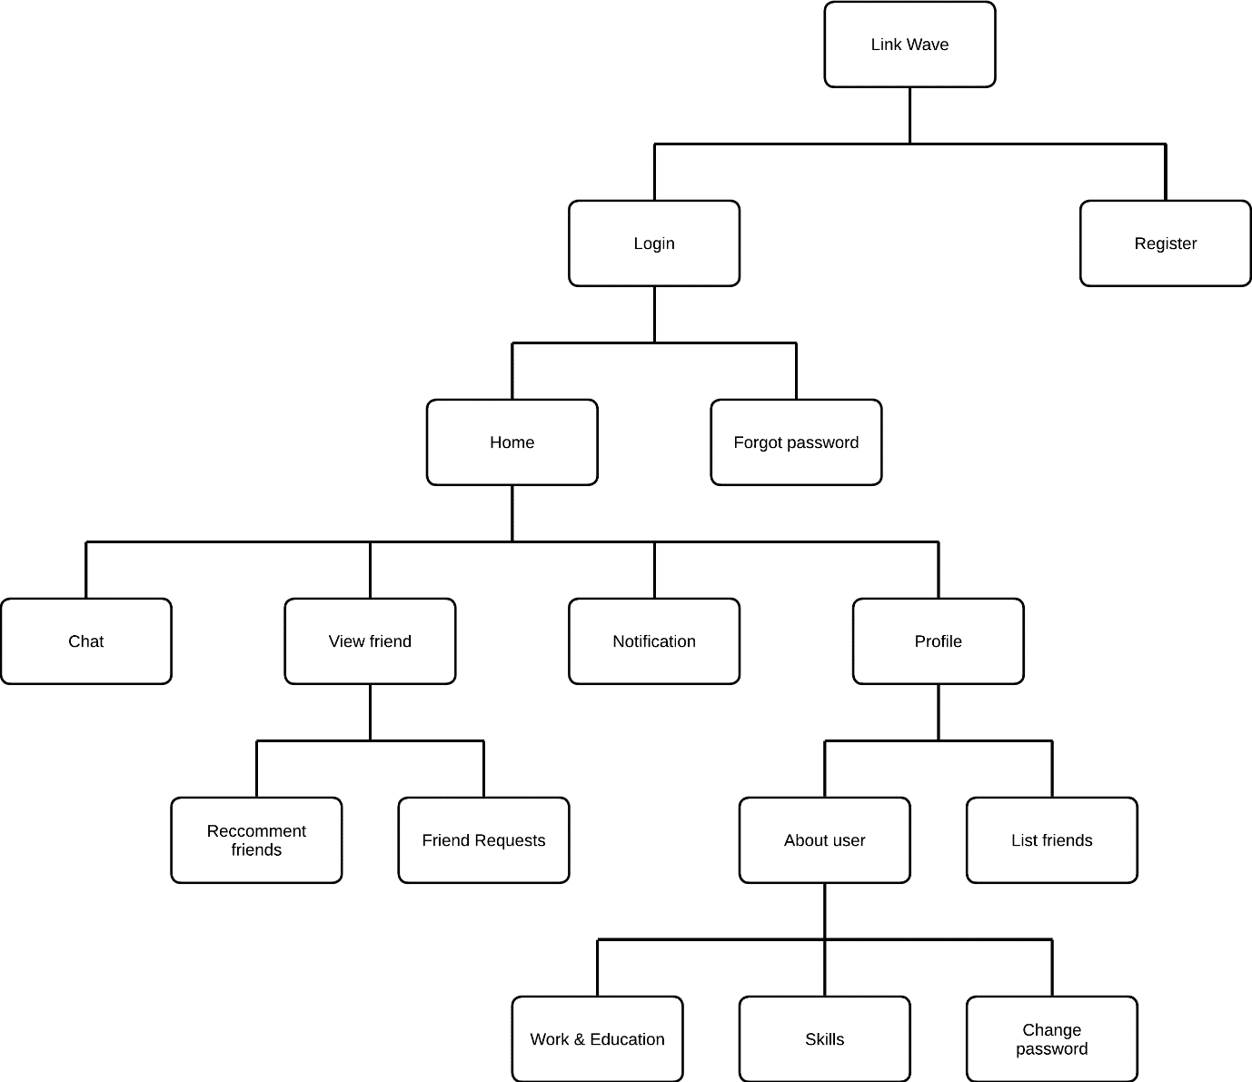

1. Sitemap website

## Usecase diagram

### User role

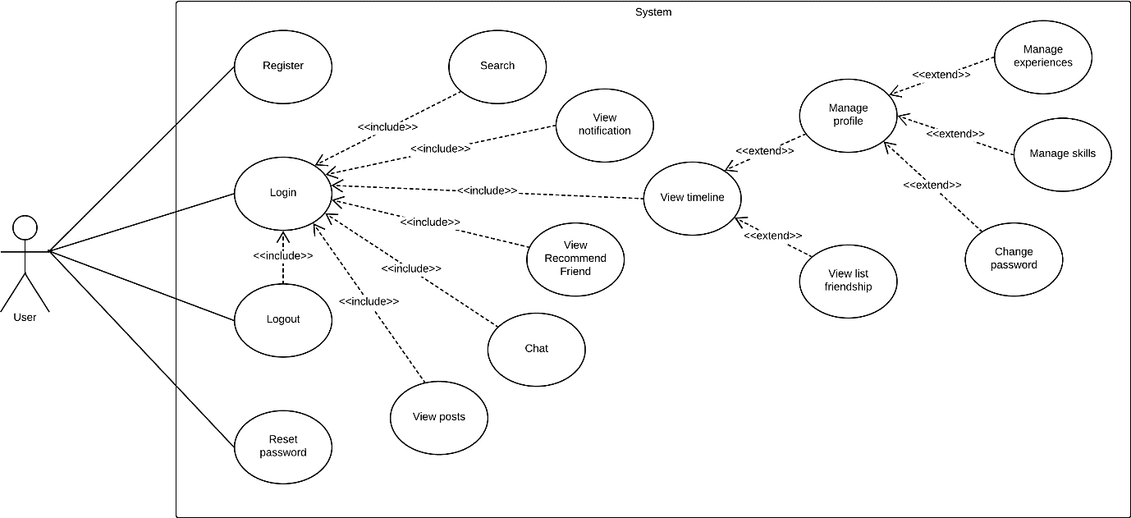

1. Use case of user role

Here's a description of the use case diagram in the image:

* Actor: There's a single actor identified as "User," which represents the person interacting with the system.
* System: The larger rectangle, named "System," encompasses various functionalities that the user can interact with.
* Use Cases:
  + Primary Functions:

Register: The user can create a new account.

Login: The user can log into the system. This function is central to the diagram, indicating that many other functions require the user to be logged in.

Logout: The user can log out of the system.

Reset Password: The user can reset their password if necessary.

* Post-Login Functions (these use cases are connected to the "Login" function, implying they are accessible after a user logs in):

View Posts: The user can view posts within the system.

Chat: The user can engage in chats.

View Recommended Friend: The system can suggest friends to the user.

View Notifications: The system displays notifications to the user.

View Timeline: The user can view their timeline of activities or posts.

View List Friendship: The user can view a list of their friends or connections.

Manage Profile: This seems to be a more complex use case that can extend into more specific actions, such as managing experiences and skills, which could refer to personal information or professional qualifications.

Change Password: The user can change their current password.

* Relationships:
  + Include Relationship: This is shown with a dashed arrow with the "include" stereotype, indicating that the target use case is included in the functionality of the source use case. For example, the "Login" use case includes "View Posts," "Chat," etc.
  + Extend Relationship: This is depicted with a dashed arrow with the "extend" stereotype, implying that the extended use case adds to the base use case under certain conditions. For example, "Manage Profile" extends into "Manage Experiences" and "Manage Skills."

### Admin role

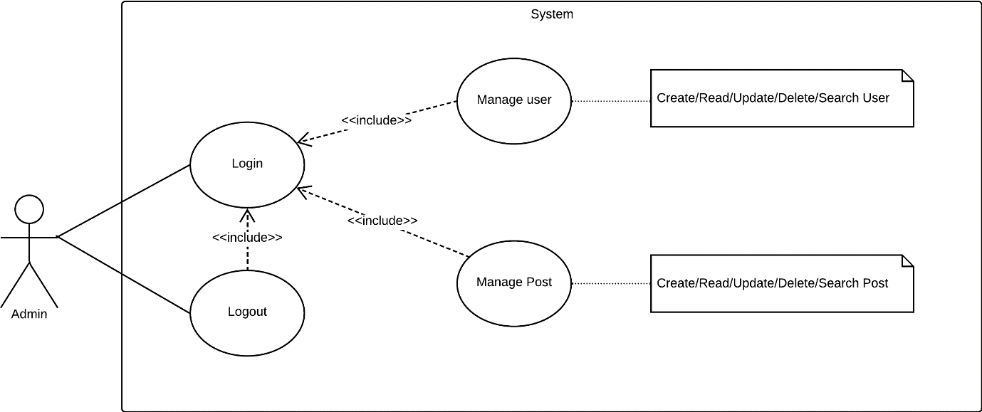

1. Usecase of admin role

Here's a breakdown of the use case diagram:

* Actor: As with the previous diagram, there is one actor identified as "Admin".
* System: This is indicated by the boundary that encapsulates the use cases.
* Use Cases:
  + Login: The admin can log into the system, which is a prerequisite for accessing other functionalities.
  + Logout: The admin can log out of the system.
* Secondary Use Cases (possibly only accessible after logging in):
  + Manage User: This use case is connected to the "Login" use case with an "include" relationship, suggesting that managing users is a function that is part of the login process. This use case further expands into CRUD (Create, Read, Update, Delete) and Search functionalities specific to users.
  + Manage Post: Similar to "Manage User", this use case is connected to the "Login" and involves CRUD and Search functionalities, but it pertains to posts rather than user accounts.

## Flow Chart

### Register

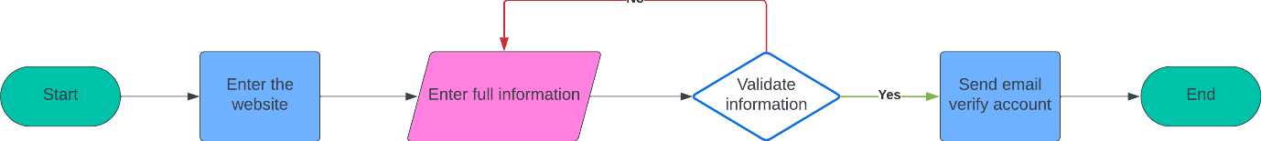

1. Register function

Here’s a step-by-step breakdown:

* Start: This is the initial step where the user begins the registration process.
* Enter the website: The user accesses the website where they wish to register.
* Enter full information: The user is prompted to fill in all required information, such as name, email, password, etc.
* Validate information: This is a decision point where the system checks if the information provided by the user is valid. If not, the process loops back to the "Enter full information" step (indicated by the red arrow) for the user to correct or complete their information.
* Send email to verify account: If the information is validated (as indicated by the "Yes" path from the decision diamond), the system proceeds to send a verification email to the user's provided email address.
* End: This is the final step of the process after the email has been sent, concluding the registration function.

### Login

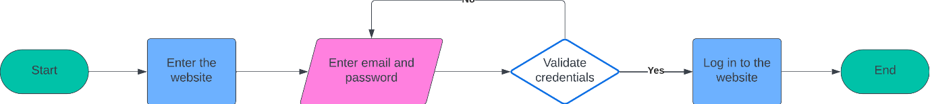

1. Login function

Here's what each step represents:

* Start: The initiation point where a user begins the login process.
* Enter the website: The user navigates to the website's login page.
* Enter email and password: The user is prompted to input their email address and password into the designated fields.
* Validate credentials: This step is a decision node where the system checks the entered credentials against its records to see if they match an existing account. If the credentials are incorrect, the process loops back to the "Enter email and password" step (indicated by the white arrow) for the user to try again.
* Log in to the website: If the credentials are validated (following the "Yes" path), the system allows the user to access their account and proceeds to the website's user-specific area.
* End: This marks the conclusion of the login process after successful authentication.

### Reset password

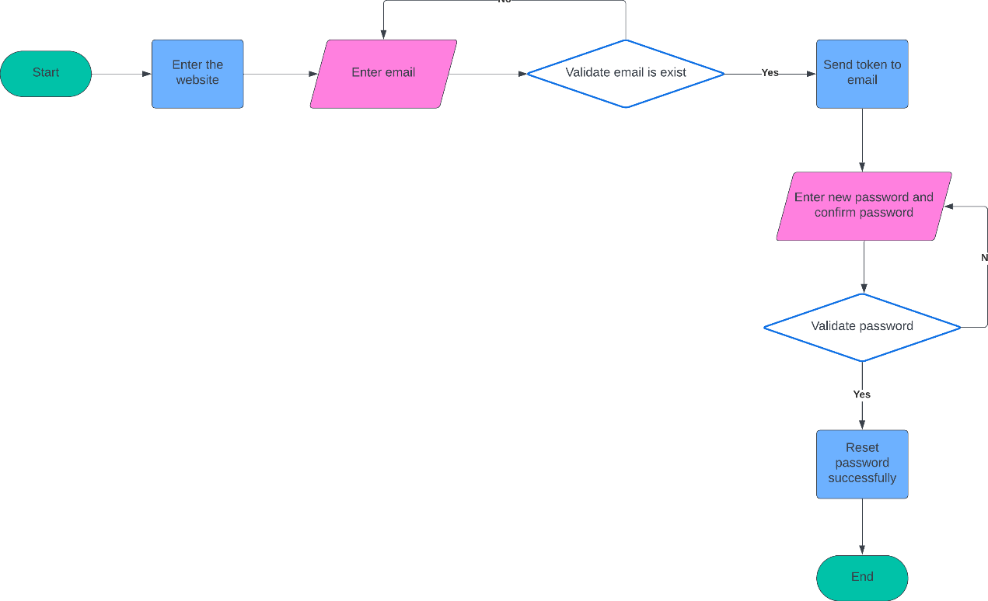

1. Reset password function

Here's the detailed description:

* Start: The initial point where a user decides to reset their password.
* Enter the website: The user navigates to the given website and finds the option to reset the password.
* Enter email: The user is prompted to enter their email address into the reset password feature.
* Validate email is exist: This is a decision step where the system checks if the provided email address exists in the database. If the email does not exist, the flow ends, indicating that the process cannot continue without a valid email account on record.
* Send token to email: If the email exists, the system sends a token or a link to the user's email address to proceed with password resetting.
* Enter new password and confirm password: The user receives the token or link, uses it to access the reset password area, and enters a new password along with a confirmation of that password.
* Validate password: This decision step verifies if the new password meets the system's criteria and if the confirmation matches the new password. If the validation fails, the flow loops back to the "Enter new password and confirm password" step.
* Reset password successfully: Upon successful validation, the password is reset in the system.
* End: The process concludes, and the user can now log in with the new password.

### Search friend



1. Search friend function

Here’s a step-by-step explanation of the process:

* Start: The user initiates the friend search process.
* Login to the website: The user logs into their account on the website.
* Enter friend name: The user is prompted to enter the name of the friend they are looking for into a search field.
* Show the result: After entering the name and submitting the search request, the website processes the search and displays the results to the user.
* End: The process concludes after the search results have been presented to the user.

### Update profile



1. Update profile function

Here’s the process outlined in the chart:

* Start: This is where the user initiates the update profile process.
* Login to the website: The user must log in to their account on the website to make changes to their profile.
* Go to profile page: After logging in, the user navigates to their profile page where they can make updates.
* Enter full information: The user enters or updates their personal information, such as name, contact details, bio, etc.
* Validate information: This step represents a decision point where the system checks the new information entered by the user for completeness and accuracy. If the information is not valid (the "No" path), the process redirects back to the "Enter full information" step for the user to make corrections.
* Update profile successfully: If the information is validated ("Yes" path), the profile is updated with the new details.
* End: The process concludes, and the user's profile has been successfully updated.

### Change password



1. Change passwrod function

Here's a description of each step:

* Start: The point at which the user decides to change their password.
* Login to the website: The user must first log into the website with their current credentials to access their account settings.
* Go to profile page: After successfully logging in, the user navigates to their profile page or directly to the password change option within their account settings.
* Enter old password, new password, confirm password: On the password change screen, the user must enter their current (old) password and then enter the new password twice, once to set it and again to confirm it, ensuring they've typed it correctly.
* Validate password: The system checks the entered passwords to confirm that the old password is correct, the new password meets any specified security requirements, and that the new password has been entered identically in both fields. If there’s an issue (following the "No" path), the process loops back to allow the user to re-enter their passwords.
* Change password successfully: If all entered passwords are validated (following the "Yes" path), the system updates the user's password with the new one.
* End: The process concludes, indicating the user has successfully changed their password.

### Create new post



1. Create new post function

Here's the flow explained:

* Start: The user initiates the process of creating a new post.
* Login to the website: The user must first log into their account on the website to access the posting feature.
* Go to create new post: Once logged in, the user navigates to the section where they can create a new post. This is typically found in the user's dashboard or in a clearly labeled section of the site.
* Enter content and choose image (optional): In the post creation area, the user enters the text for their new post. They also have the option to add an image to accompany the text. The "optional" label indicates that adding an image is not required to proceed.
* Show post: After the content (and possibly an image) is added, the post is published or previewed, showing how it will appear on the website.
* End: The process concludes, and the new post is now created and possibly visible to other users, depending on the website's functionality.

## Mockup UI design

### Register

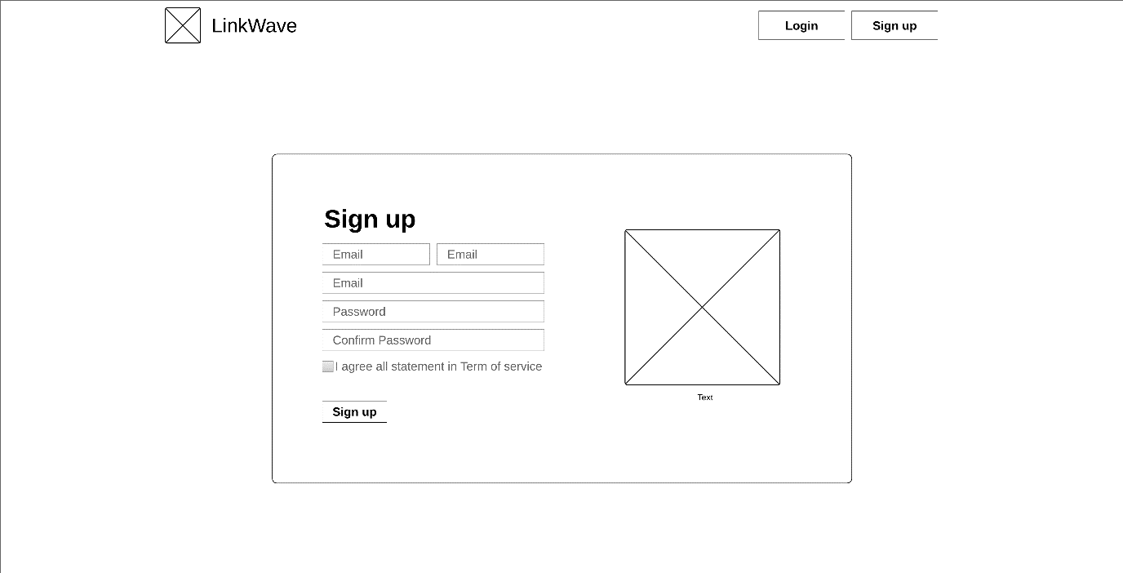

1. Register page

### Login

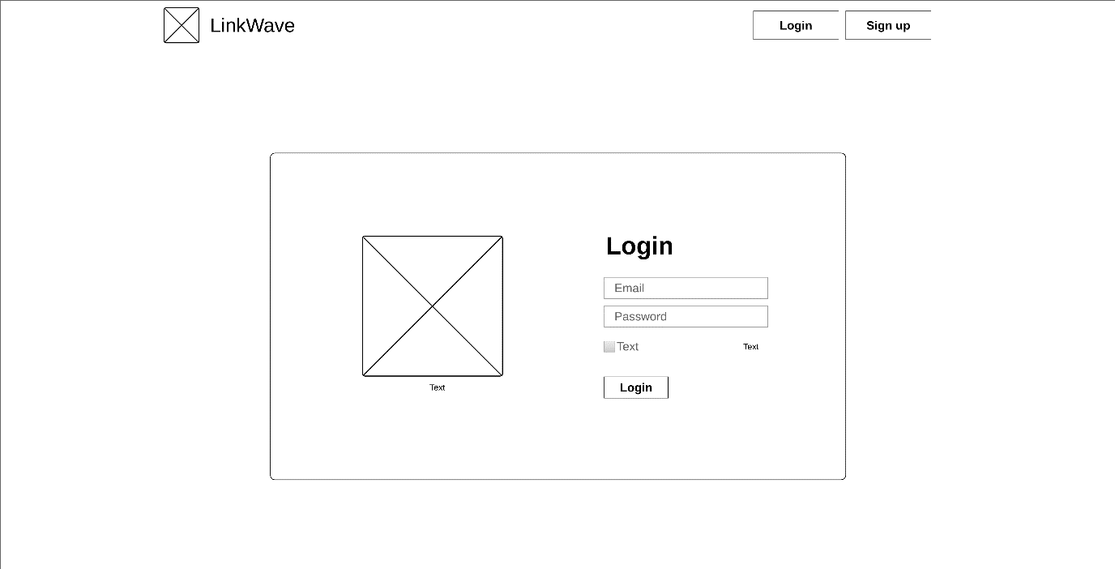

1. Login page

### Home

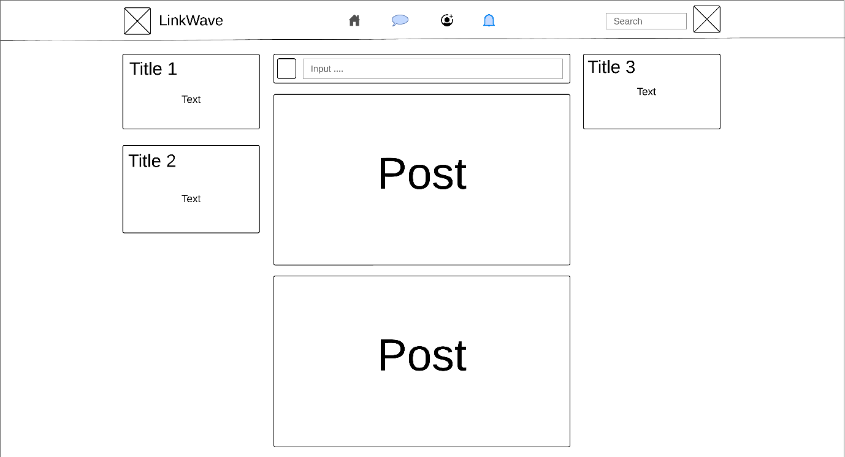

1. Home page

### Chat message

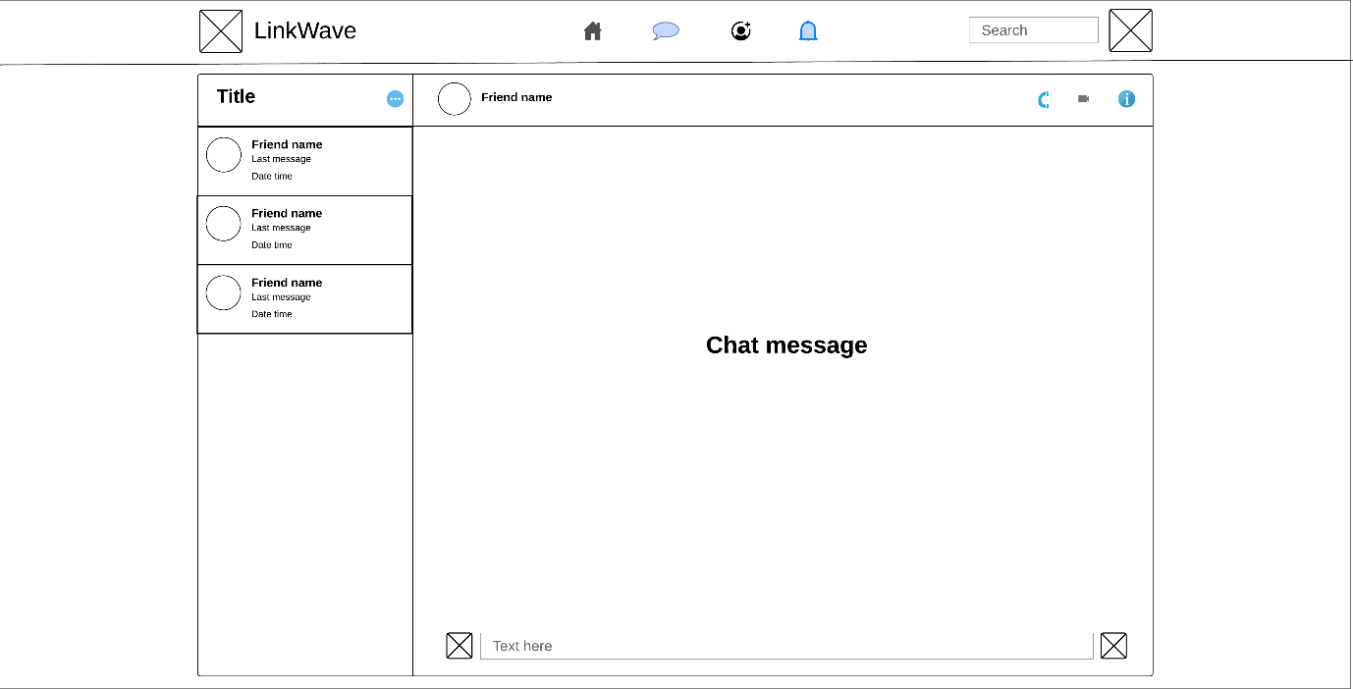

1. Chat message page

### Friend

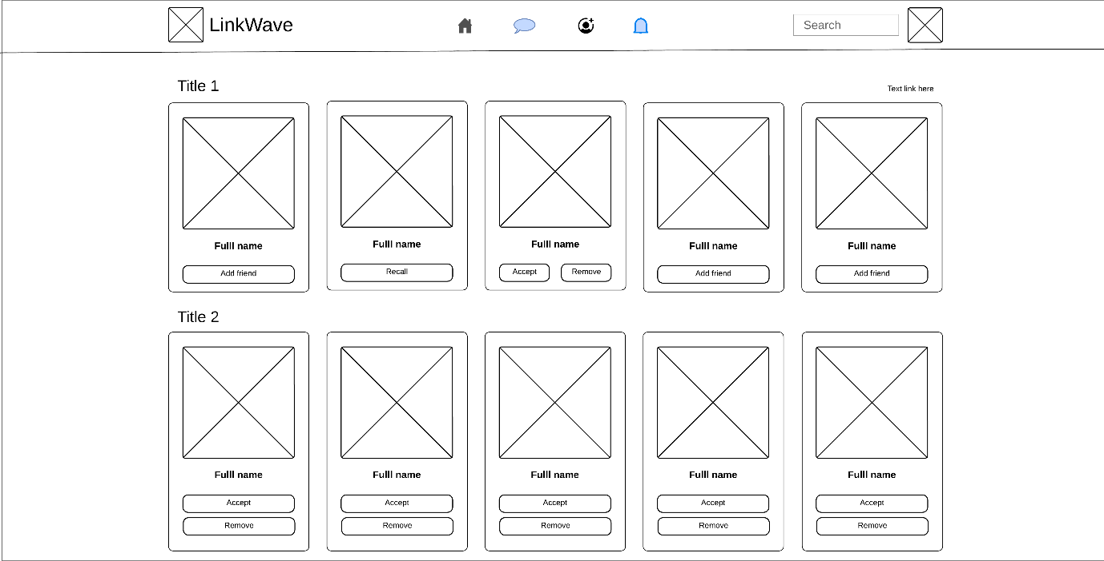

1. Add Friend page

### Notification

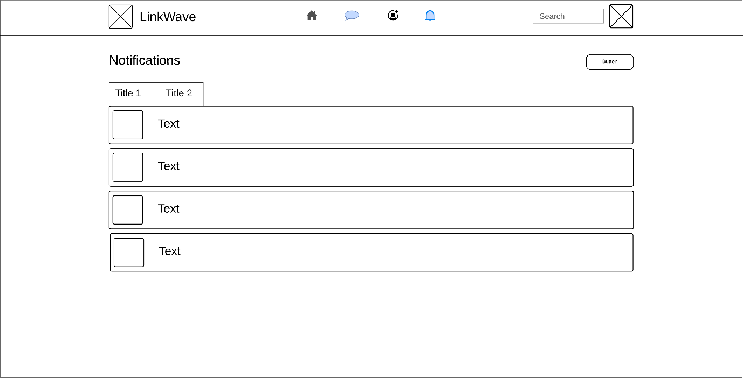

1. Notification page

### Profile

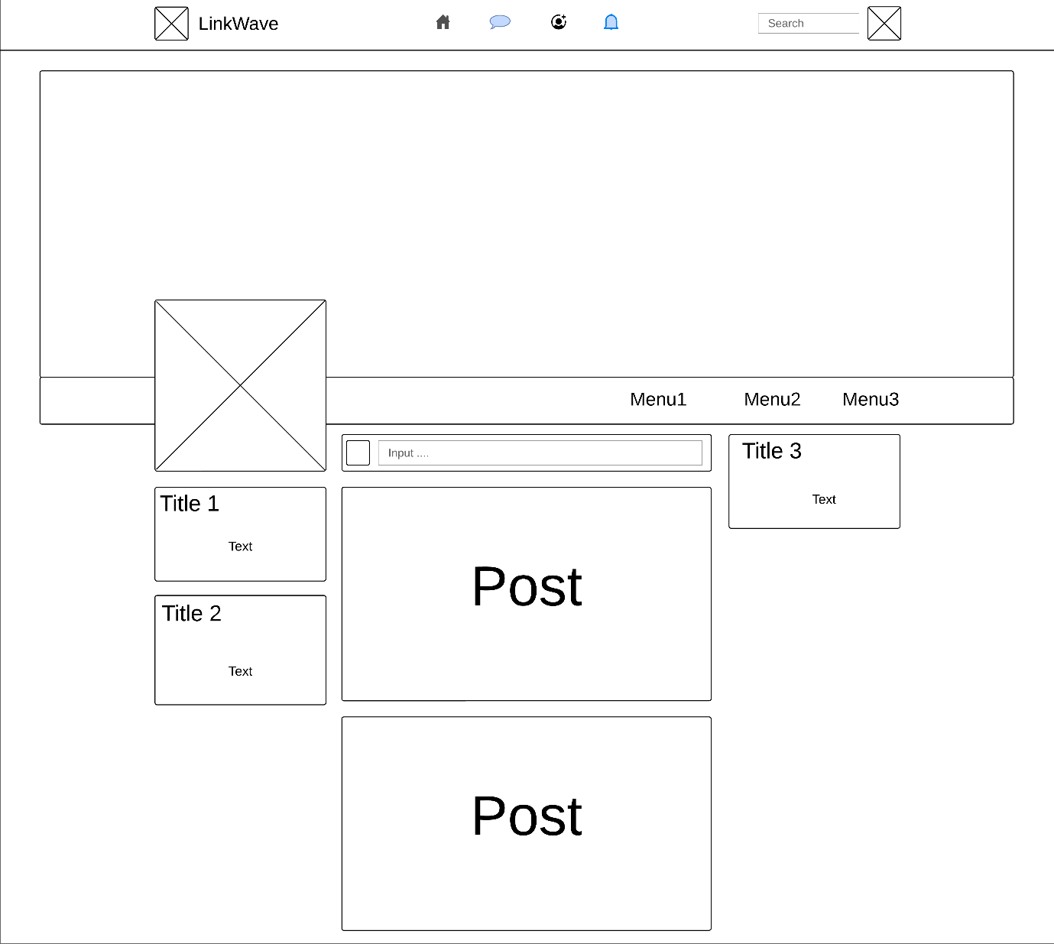

1. Profile page

### About user

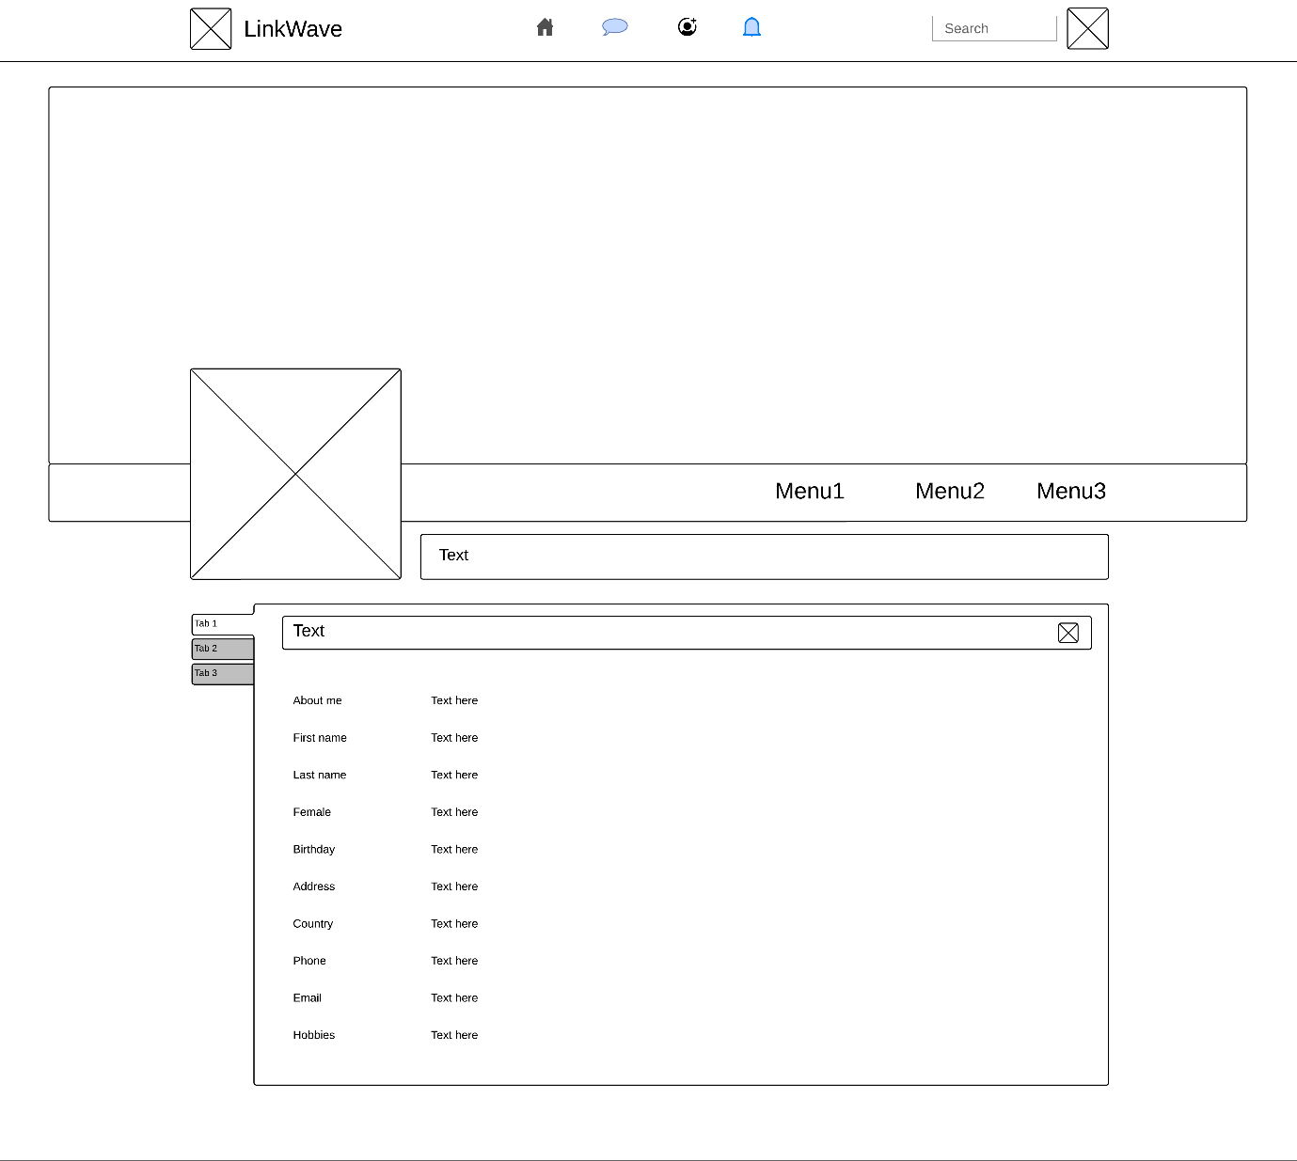

1. About user page

### Friend list

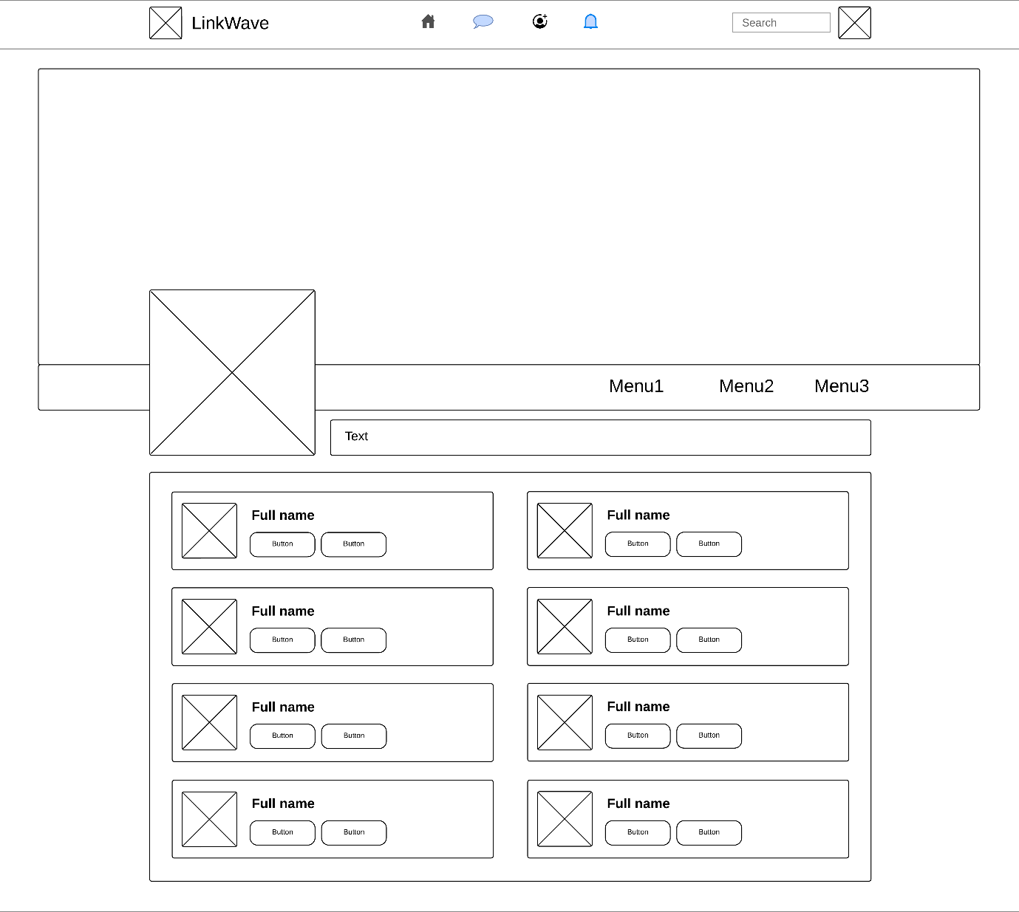

1. Friend list page

# METHODOLOGIES AND SOFTWARE DEVELOPMENT PROCESS

## Software development process

In this project, I've implemented the Scrum framework, designed to facilitate seamless adaptation to evolving conditions and user needs. With its emphasis on flexibility, Scrum enables frequent re-prioritization and short release cycles, fostering continuous learning and improvement within the team. (DRUMOND, 2024)

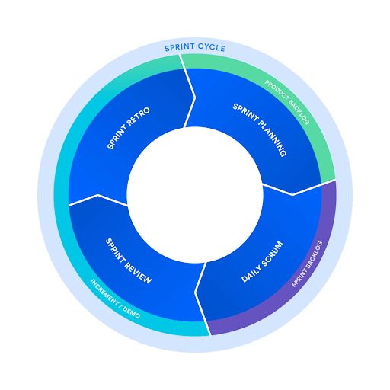

1. Software development process model

## Software development methodologies

In today's highly competitive IT industry, the focus has shifted towards developing high-quality products. Speedy delivery is no longer the sole priority; customer satisfaction is equally important. This shift has led to the adoption of rigorous testing techniques and tools, creating complex challenges in project management and team coordination at all levels.

Companies are now prioritizing the delivery of quality products that meet customer expectations. Each software development life cycle model has its significance and limitations. Choosing a specific model allows for tailored processes and structures to suit various types of products and projects. For my project, I have opted for the Agile methodology as it aligns well with these goals and requirements (Singh, et al., 2019).

As per the definition from "AgileAlliance.org," "Agile" serves as a broad term encompassing methodologies and practices aimed at improving software development through collaborative efforts. It is rooted in the Agile Software Development Manifesto and its 12 principles.

These principles are inspired by the insights found in the Agile Manifesto by Cunningham and include the following key ideas:

* The highest priority is to satisfy the customer through continuous and early software development.
* It's crucial to maximize the amount of work not done, emphasizing efficiency.
* Development teams should regularly reflect on their processes during fixed intervals to enhance productivity and make necessary adjustments.
* Creating a conducive environment for motivated individuals and entrusting them with the responsibility of delivering results is vital.
* Agile processes support accommodating changes in requirements even during the later stages of development to ensure the software's benefits for the customer (Singh, et al., 2019).

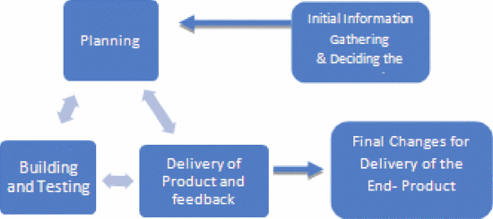

1. Depicting the implementation in development life cycle

## Conclusion

I’ve decided to utilize the Scrum methodology for this project, finding it to be the most suitable approach among the various available models. While it may not be universally acclaimed as the best, its adaptability to changing requirements and iterative nature align perfectly with the project’s needs. Embracing Scrum will require a shift in my workflow, as it emphasizes regular sprints, constant collaboration, and frequent review cycles. However, I am committed to implementing Scrum to ensure the development of the highest quality product possible, leveraging its framework to enhance communication, transparency, and ultimately, project success.

# IMPLEMENTATION AND EXPLAINATION

## Backend

### Folder structure

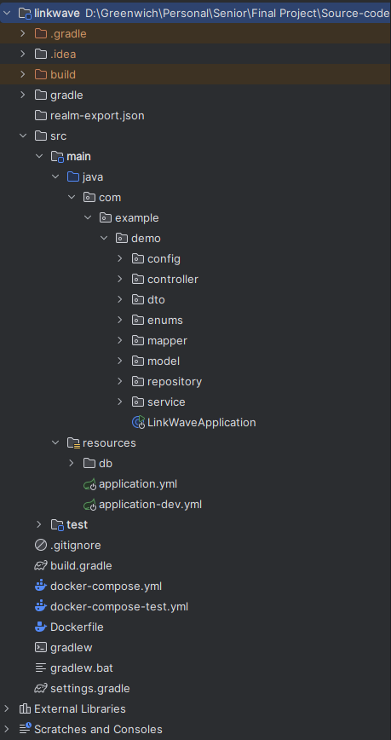

1. Backend’s folder structure

### Setup environtment

#### Docker compose

version: '3'  
  
services:  
 linkwave-db:  
 image: postgres:15  
 container_name: linkwave-db  
 restart: unless-stopped  
 environment:  
 POSTGRES_USER: linkwave_user  
 POSTGRES_PASSWORD: ndquang@2002  
 POSTGRES_DB: linkwave_db  
 ports:  
 - "5005:5432"  
 volumes:  
 - postgres_data:/var/lib/postgresql/data  
 networks:  
 - linkwave-network  
  
 linkwave-keycloak:  
 image: bitnami/keycloak:22.0.5  
 depends_on:  
 - keycloak-db  
 container_name: linkwave-keycloak  
 environment:  
 PROXY_ADDRESS_FORWARDING: "true"  
 DB_VENDOR: postgres  
 DB_ADDR: keycloak-db  
 DB_DATABASE: keycloak_db  
 DB_USER: linkwave_user  
 DB_PASSWORD: ndquang@2002  
 KEYCLOAK_ADMIN: admin  
 KEYCLOAK_ADMIN_PASSWORD: admin  
 volumes:  
 - ./realm-export.json:/opt/bitnami/keycloak/data/import/realm-export.json  
 ports:  
 - "8081:8080"  
 restart: unless-stopped  
 networks:  
 - linkwave-network  
  
 keycloak-db:  
 image: postgres:15  
 container_name: keycloak-db  
 restart: unless-stopped  
 ports:  
 - "5008:5432"  
 environment:  
 POSTGRES_DB: keycloak_db  
 POSTGRES_USER: linkwave_user  
 POSTGRES_PASSWORD: ndquang@2002  
 volumes:  
 - keycloak-db-data:/var/lib/postgresql/data  
 networks:  
 - linkwave-network  
  
 kafdrop:  
 image: obsidiandynamics/kafdrop  
 container_name: kafdrop  
 restart: unless-stopped  
 ports:  
 - "9000:9000"  
 environment:  
 KAFKA_BROKERCONNECT: "kafka:29092"  
 depends_on:  
 - "kafka"  
 networks:  
 - linkwave-network  
  
 kafka:  
 image: obsidiandynamics/kafka  
 container_name: kafka  
 restart: unless-stopped  
 ports:  
 - "2181:2181"  
 - "9092:9092"  
 environment:  
 KAFKA_LISTENERS: "INTERNAL://:29092,EXTERNAL://:9092"  
 KAFKA_ADVERTISED_LISTENERS: "INTERNAL://kafka:29092,EXTERNAL://localhost:9092"  
 KAFKA_LISTENER_SECURITY_PROTOCOL_MAP: "INTERNAL:PLAINTEXT,EXTERNAL:PLAINTEXT"  
 KAFKA_INTER_BROKER_LISTENER_NAME: "INTERNAL"  
 KAFKA_ZOOKEEPER_SESSION_TIMEOUT: "6000"  
 KAFKA_RESTART_ATTEMPTS: "10"  
 KAFKA_RESTART_DELAY: "5"  
 ZOOKEEPER_AUTOPURGE_PURGE_INTERVAL: "0"  
 KAFKA_CREATE_TOPICS: "linkwave:1:1"  
 networks:  
 - linkwave-network  
  
volumes:  
 postgres_data:  
 driver: local  
 keycloak-db-data:  
 driver: local  
  
networks:  
 linkwave-network:  
 driver: bridge

#### Application (dev)

spring:  
 datasource:  
 url: jdbc:postgresql://localhost:5005/linkwave_db  
 username: linkwave_user  
 password: ndquang@2002  
 flyway:  
 locations:  
 - classpath:db/migration/schema  
 - classpath:db/migration/data  
 clean-on-validation-error: true  
 jpa:  
 generate-ddl: off  
 hibernate.ddl-auto: none  
 hibernate.naming.physical-strategy: org.hibernate.boot.model.naming.PhysicalNamingStrategyStandardImpl  
 database-platform: org.hibernate.dialect.PostgreSQLDialect  
 show-sql: true  
 properties:  
 hibernate:  
 jdbc.batch_size: 20  
 order_inserts: true  
 order_updates: true  
 format_sql: true  
 show_sql: true  
 security:  
 oauth2:  
 resourceserver:  
 jwt:  
 issuer-uri: http://localhost:8081/realms/linkwave  
 jwk-set-uri: http://localhost:8081/realms/linkwave/protocol/openid-connect/certs  
 data.rest.base-path: /api  
 servlet:  
 multipart:  
 file-size-threshold: 2KB  
 max-file-size: 200MB  
 max-request-size: 215MB  
 kafka:  
 consumer:  
 bootstrap-servers: localhost:9092  
 group-id: chat-group  
 auto-offset-reset: earliest  
 producer:  
 bootstrap-servers: localhost:9092  
  
server:  
 port: 8080  
  
jwt:  
 auth:  
 converter:  
 principle-attribute: preferred_username  
  
keycloak:  
 url: http://localhost:8081  
 realm: master  
 master-client-id: admin-cli *#for master realm* client-id: document-client  
 username: admin  
 password: admin  
 roles: SUPER_ADMIN, ADMIN, USER  
 defaultRole: USER  
 token-life-span: 72000  
  
cloudinary:  
 cloud-name: dtywjboyt  
 api-key: 435254598946868  
 api-secret: LxCHcYYni46KYRnqkiemtLxL_q8

## Frontend

### Folder structure

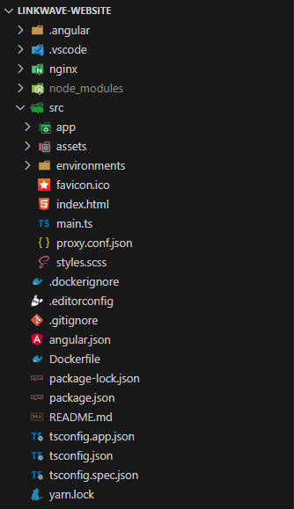

1. Frontend’s folder structure

### Config proxy

{

  "/api/*": {

    "target": "http://localhost:8080",

    "secure": false

  }

}

In Angular, when I develop a frontend application, I need to communicate with backend APIs or services. However, during development, the backend might not be hosted on the same domain or port as my frontend application. This can lead to issues with CORS (Cross-Origin Resource Sharing) policies, which restrict requests from one origin to another.

To address this, Angular provides a way to configure a proxy. The proxy configuration allows me to route certain HTTP requests from your Angular app to a different backend server during development.

Here's a breakdown of the configuration:

"/api/*": This is a path pattern indicating which requests should be proxied. In this case, any request that starts with /api/ will be proxied.

"target": "http://localhost:8080": This specifies the target URL to which requests matching the path pattern should be forwarded. In my code, requests matching /api/* will be forwarded to http://localhost:8080.

"secure": false: This indicates whether the proxy should use HTTPS (true) or HTTP (false) when forwarding requests to the target server. In this case, it's set to false, meaning it will use HTTP.

So, in summary, this configuration ensures that any HTTP requests made to paths starting with /api/ in app during development will be forwarded to http://localhost:8080, allowing me to interact with my backend API without running into CORS issues.

### Function and interface

#### Register

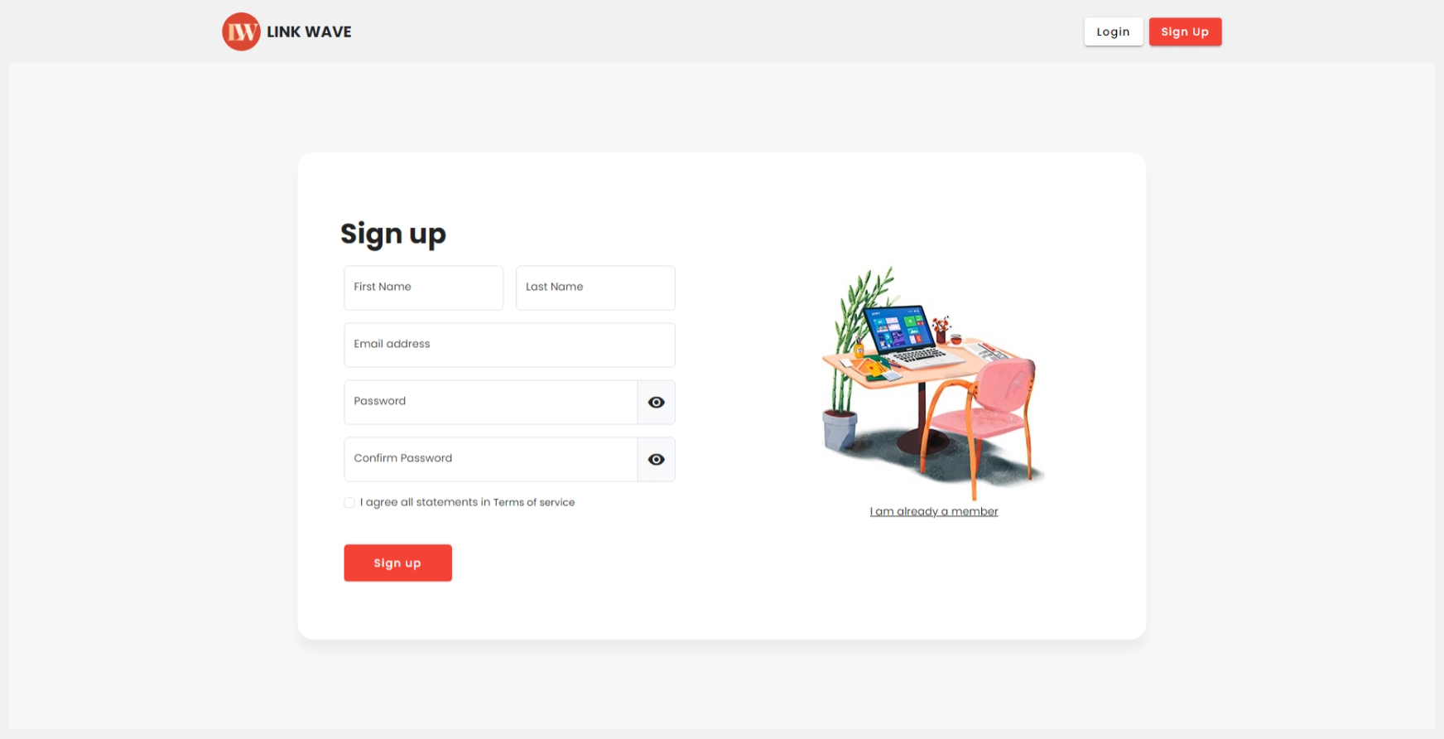

1. Register page

When the user clicks on the registration button, the system will redirect to the registration page. Here users can create their account after filling in all the fields.

If the user leaves any field blank or receives an incorrect password and password confirmation, the system displays an error message.



1. Display error when sign up (1)

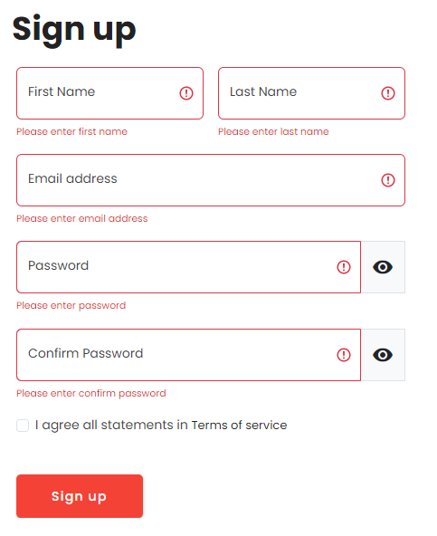

1. Enter do not enough field when siging up

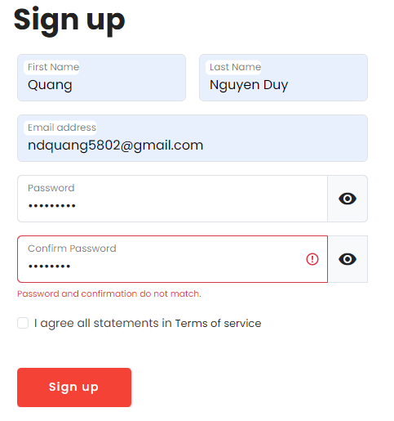

1. Enter password and confirm password do not match

After filling in all information, the system begins processing and sends a confirmation email to the user.

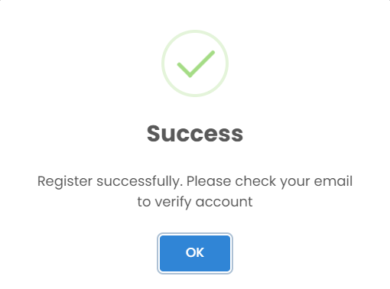

1. Display message when signing up successfully

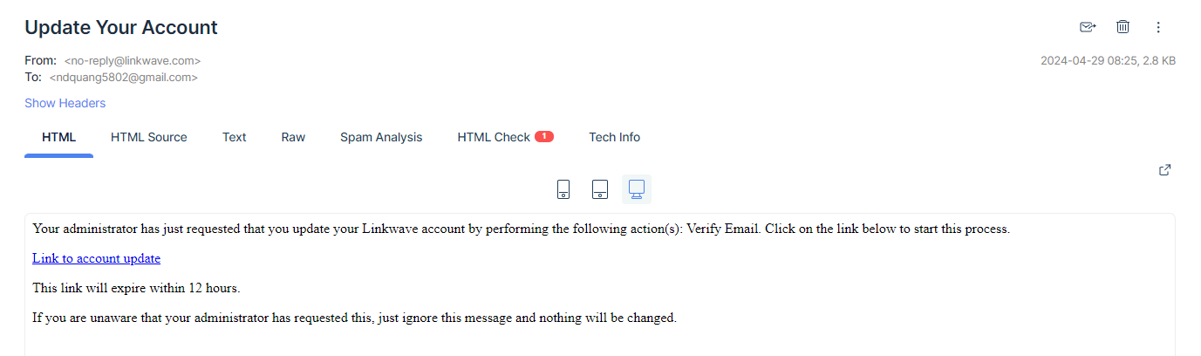

1. Email verify account

#### Login

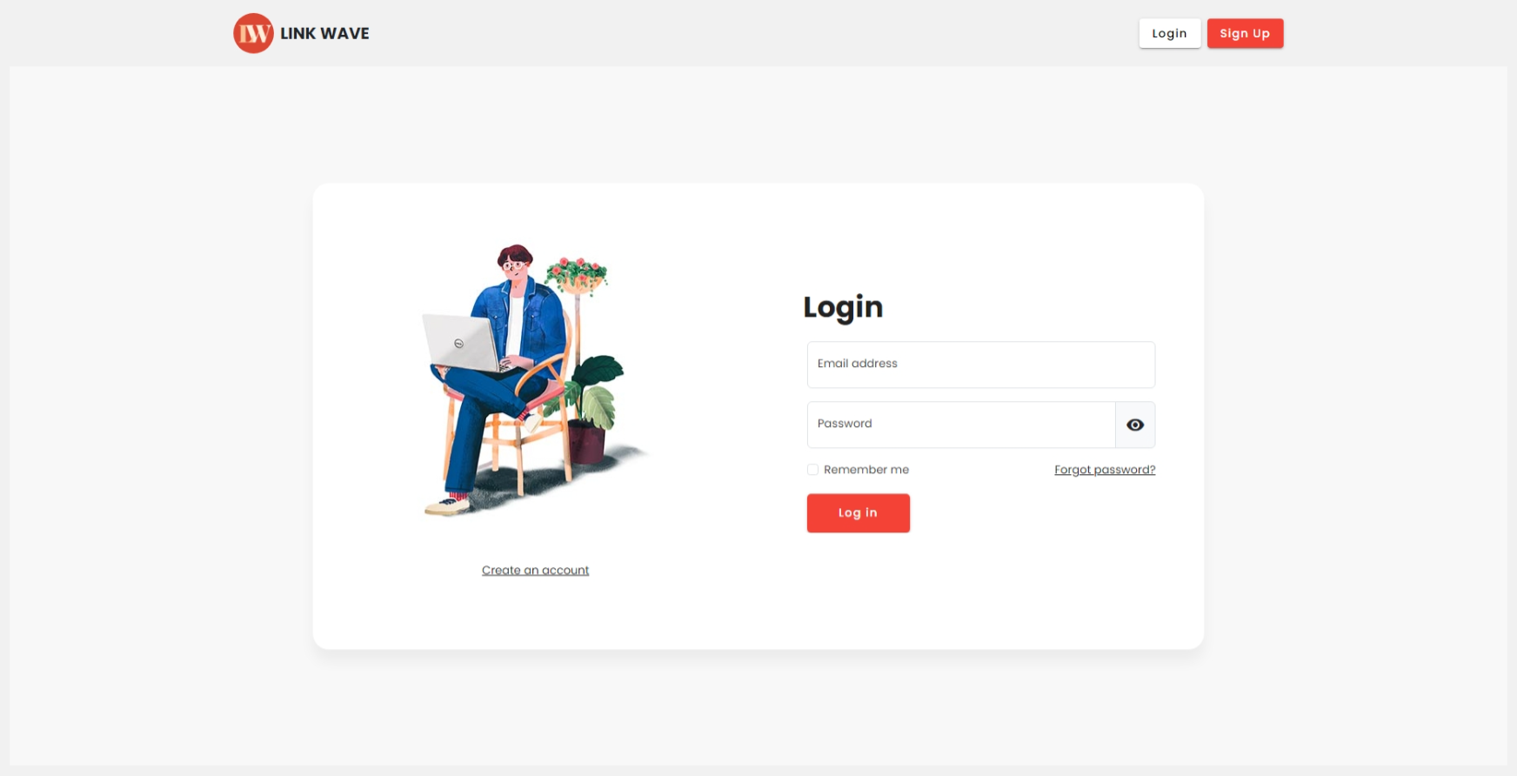

1. Login page

When the user successfully registers, the system will redirect to the login page. Here users need to enter email and password to log in.

In case the user has not confirmed the email, the system will display an error message.



1. User have to verify email before login

Besides, if the user enters the wrong email or password, the system will also display an error message.



1. Incorrect credentials

#### Forgot password

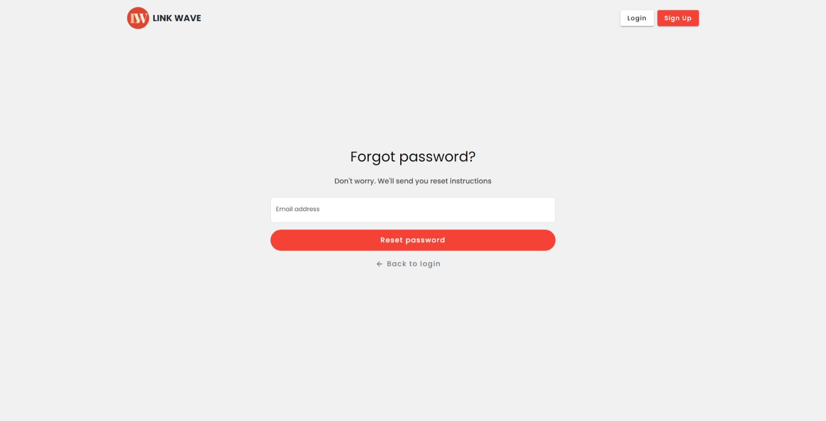

1. Forgot password page

During use, if the user forgets their password, they can reset it by going to the login page and clicking "forgot password". Users just need to enter their email and the system will send an email to change their password.

If the email does not exist, the system will display an error message.

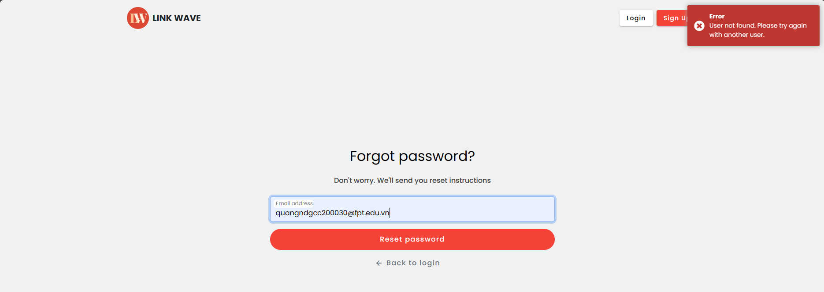

1. User does not exist in system

After receiving the email and the system checks whether the account exists, it will redirect to the email check page. Here, if the user does not receive the email after 1 minute, they can click resend the email to send it again.

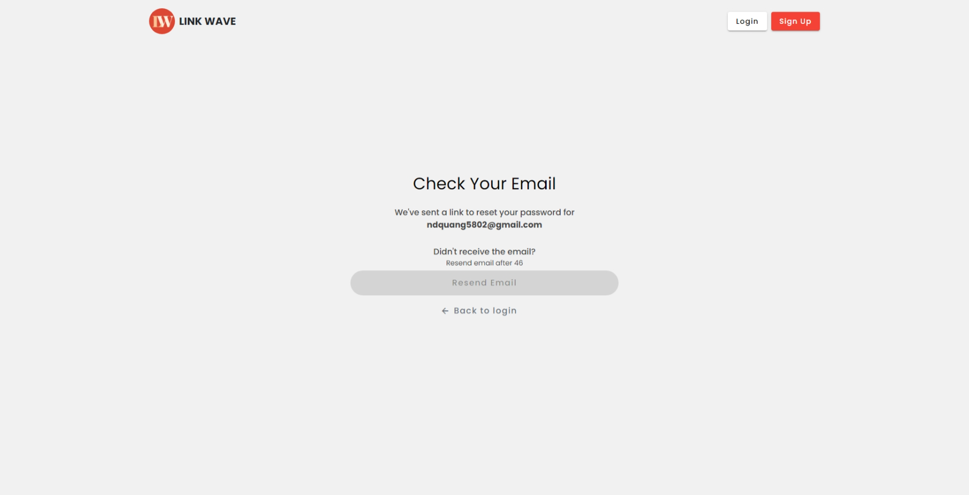

1. Check email to reset password

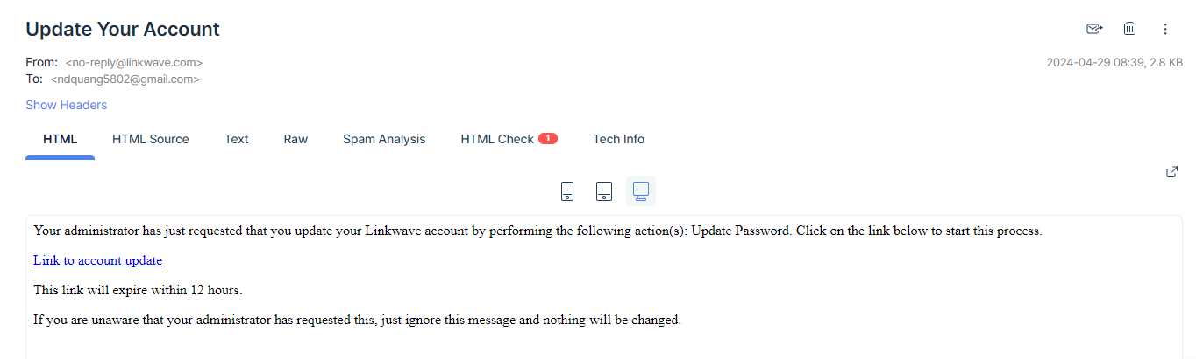

1. Email to reset password

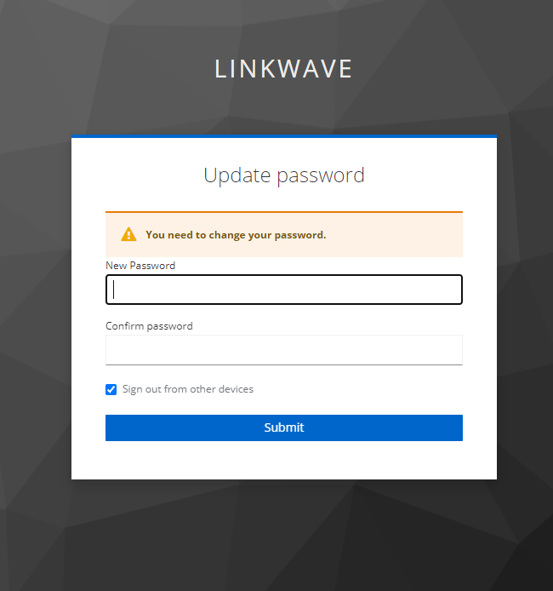

1. Enter new password and confirm password

#### Home

After successfully logging in, the system will redirect to the home page. Here users can surf to see other users' posts.

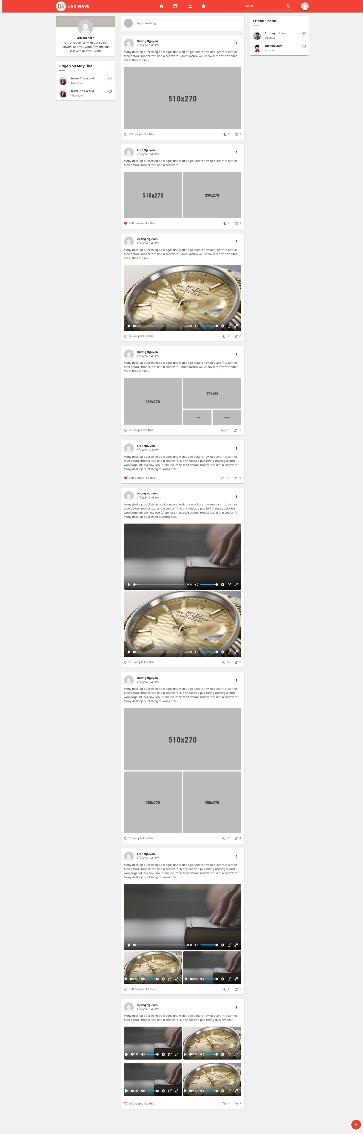

1. Home page

#### Manage profile

If the user wants to update personal information, they will go to "Profile" and select "About". Because the account is newly created, it only has information when the user registered.

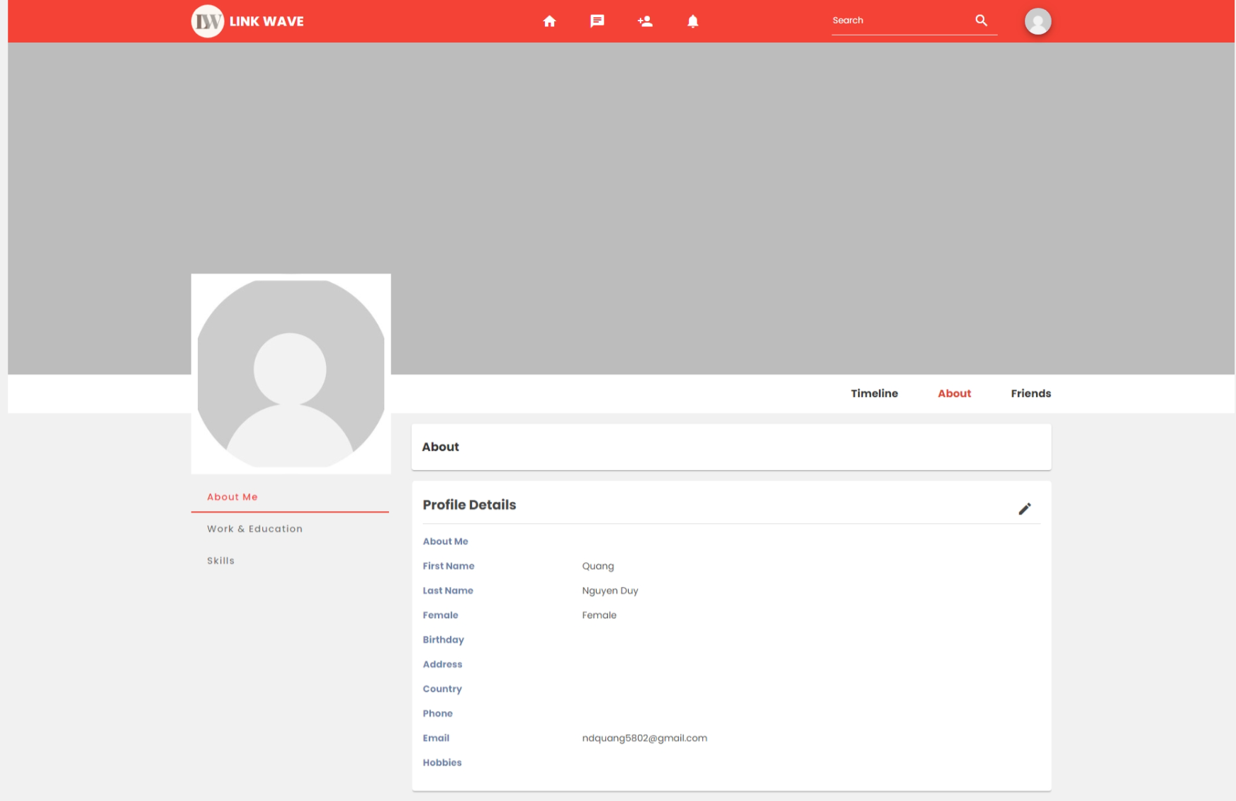

1. About user page

If you want to update information, users need to click on the pen icon

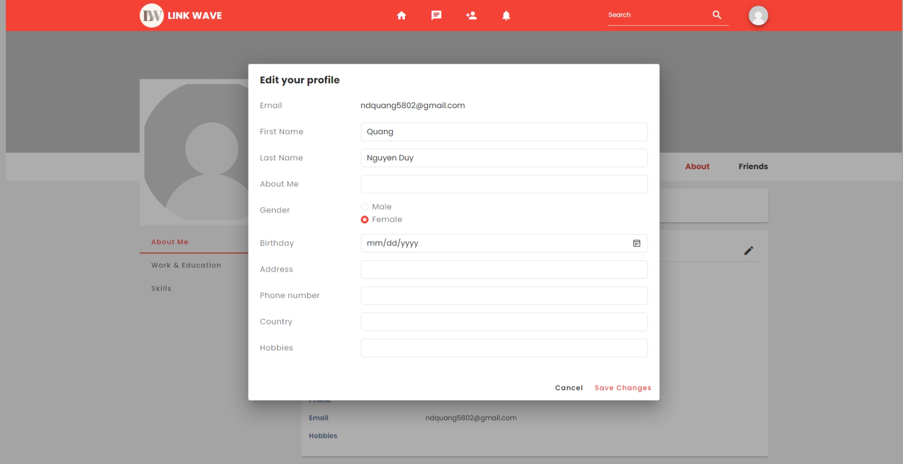

1. Update personal information

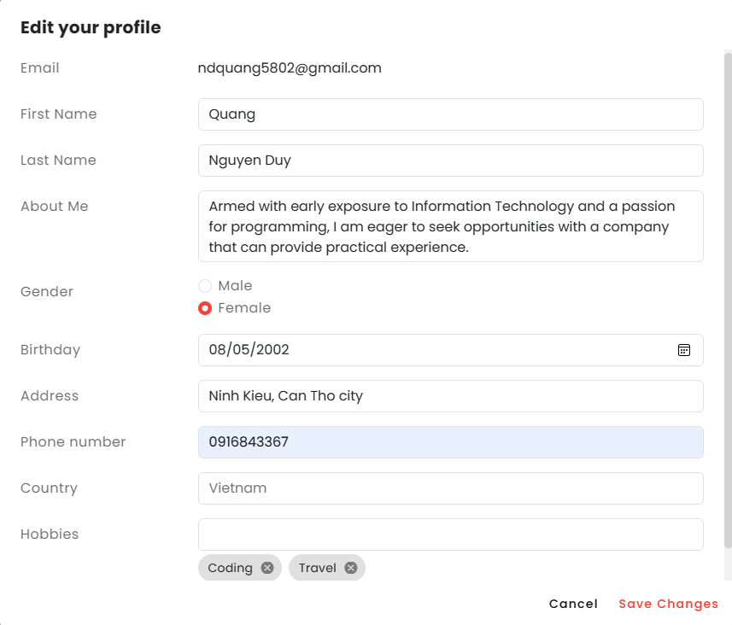

1. Enter all information when edit profile

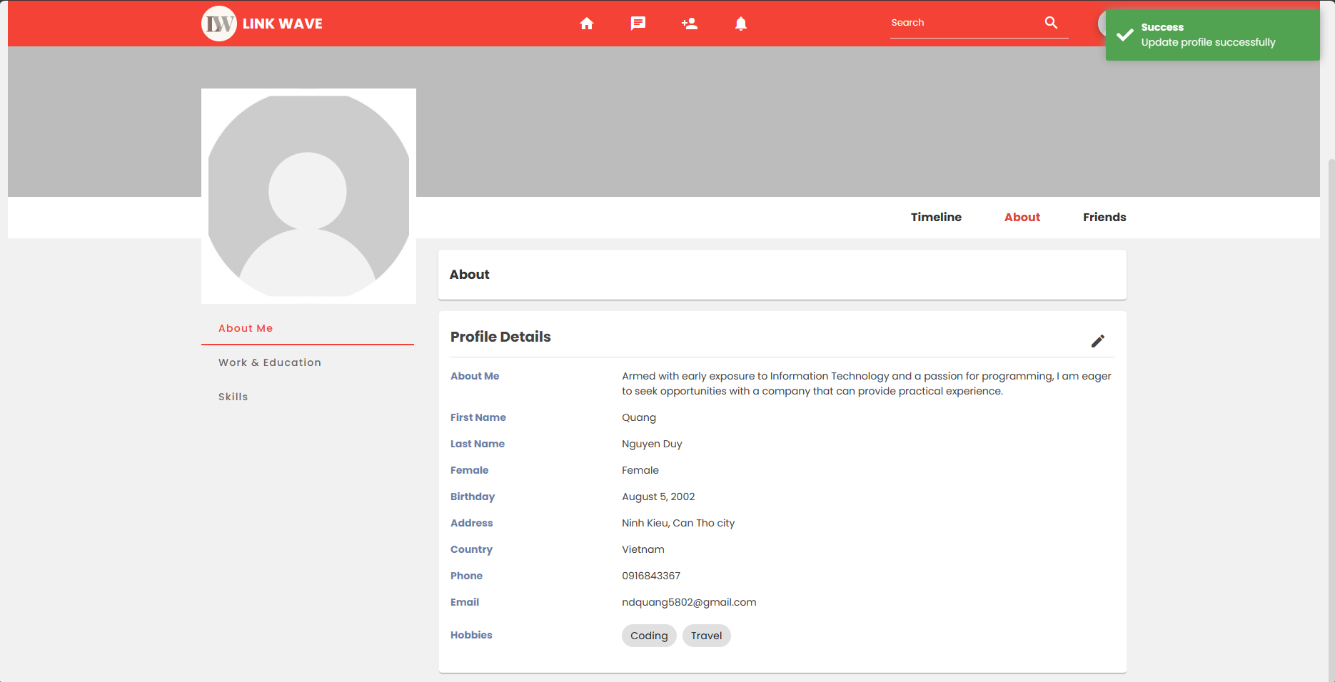

1. Edit profile successfully

#### Manage experience

In the experience management section, I divide it into two parts: education and work.

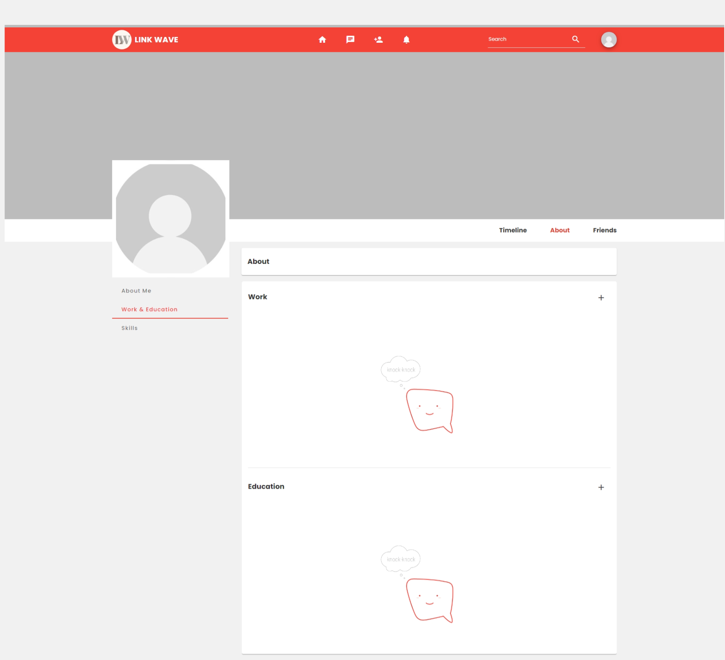

1. Manage experience

In the experience management section, I divide it into two parts: education and work.

First about work. To be able to add, users will click on the plus icon.

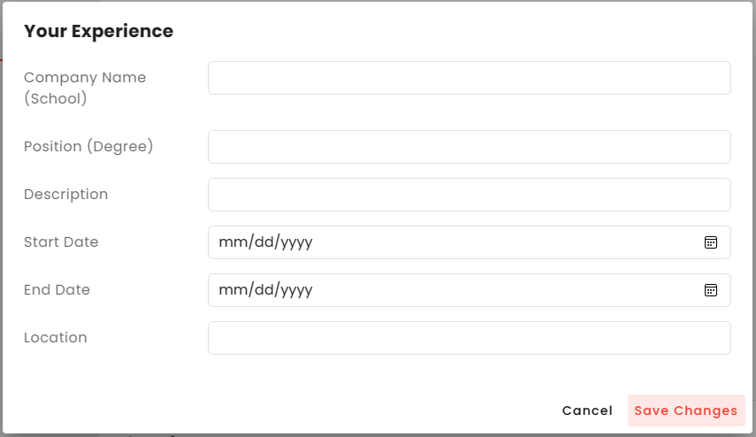

1. Add new work experience

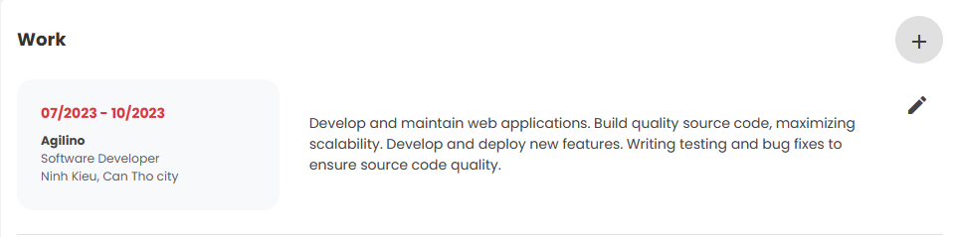

1. A work was added

If the user is still working at that company, just leave the end date blank

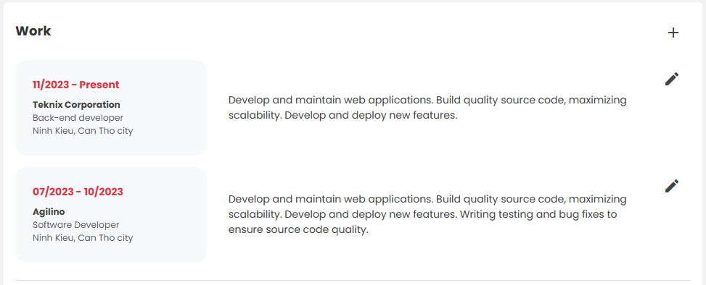

1. Add more work experience

Next is about education. To be able to add, users will click on the plus icon.

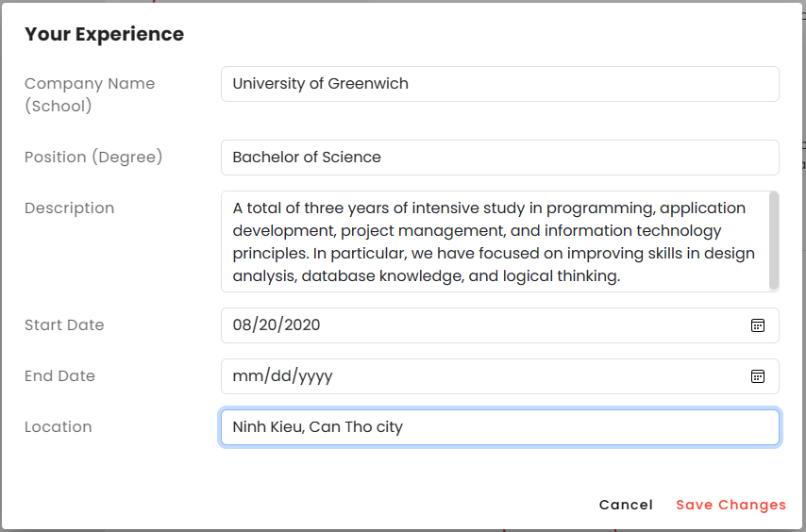

1. Add new education



1. New education was added

#### Manage skills

Next is the user skill management section. Here they can add the skills they currently have.

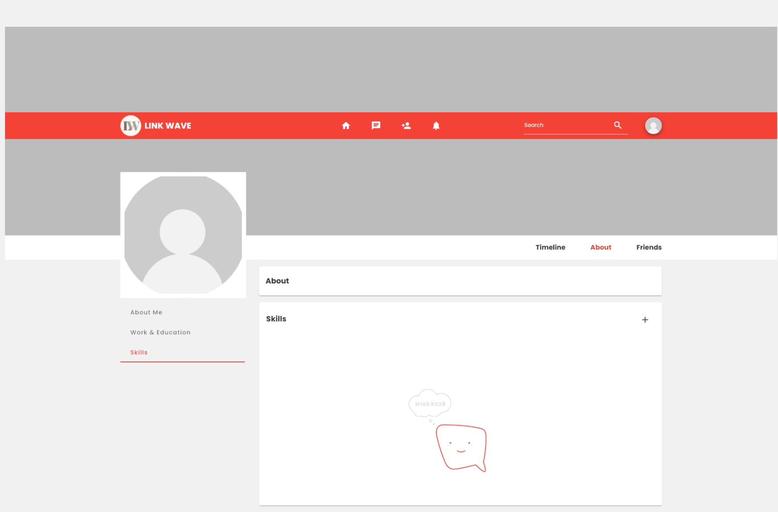

1. Manage skills

To be able to add, users will click on the plus icon.

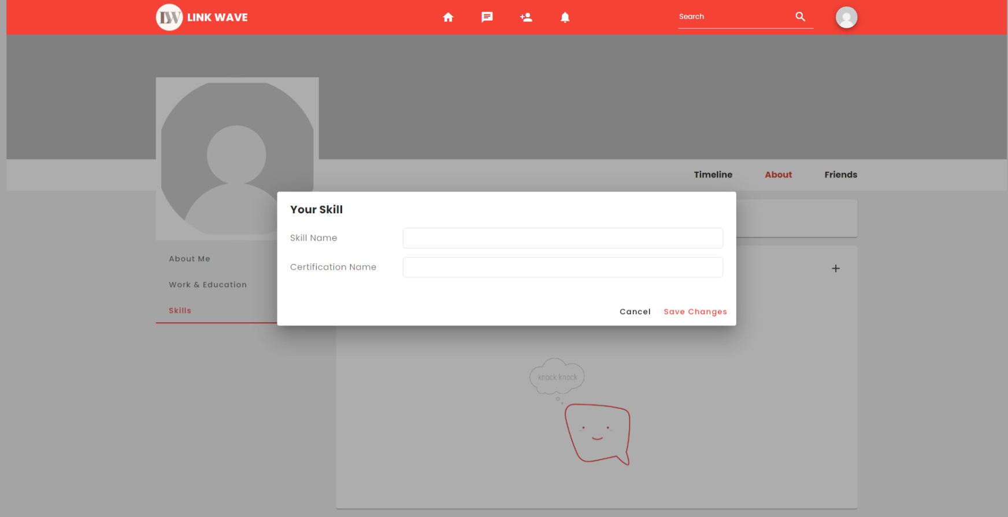

1. Add new skill

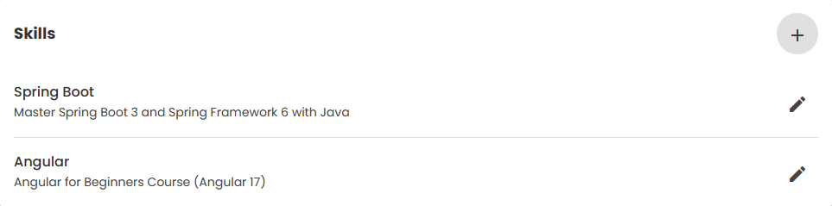

1. New skills was added

#### Change avatar

When needing to change the avatar image, the user points to the avatar image and clicks "Change Picture".

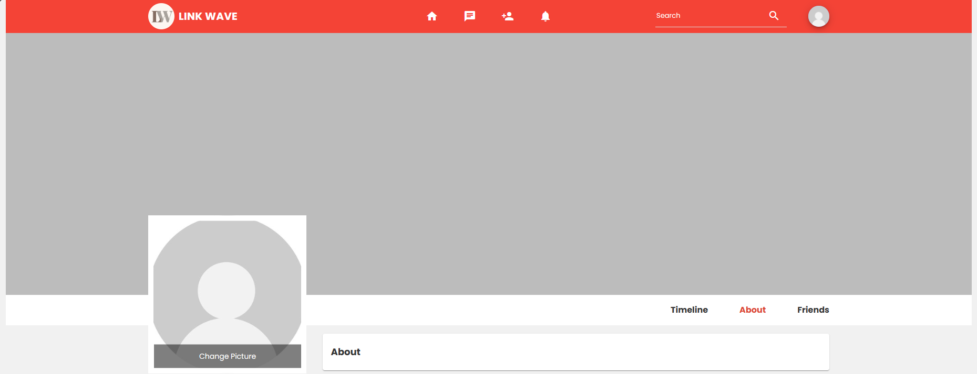

1. Hover to change avatar

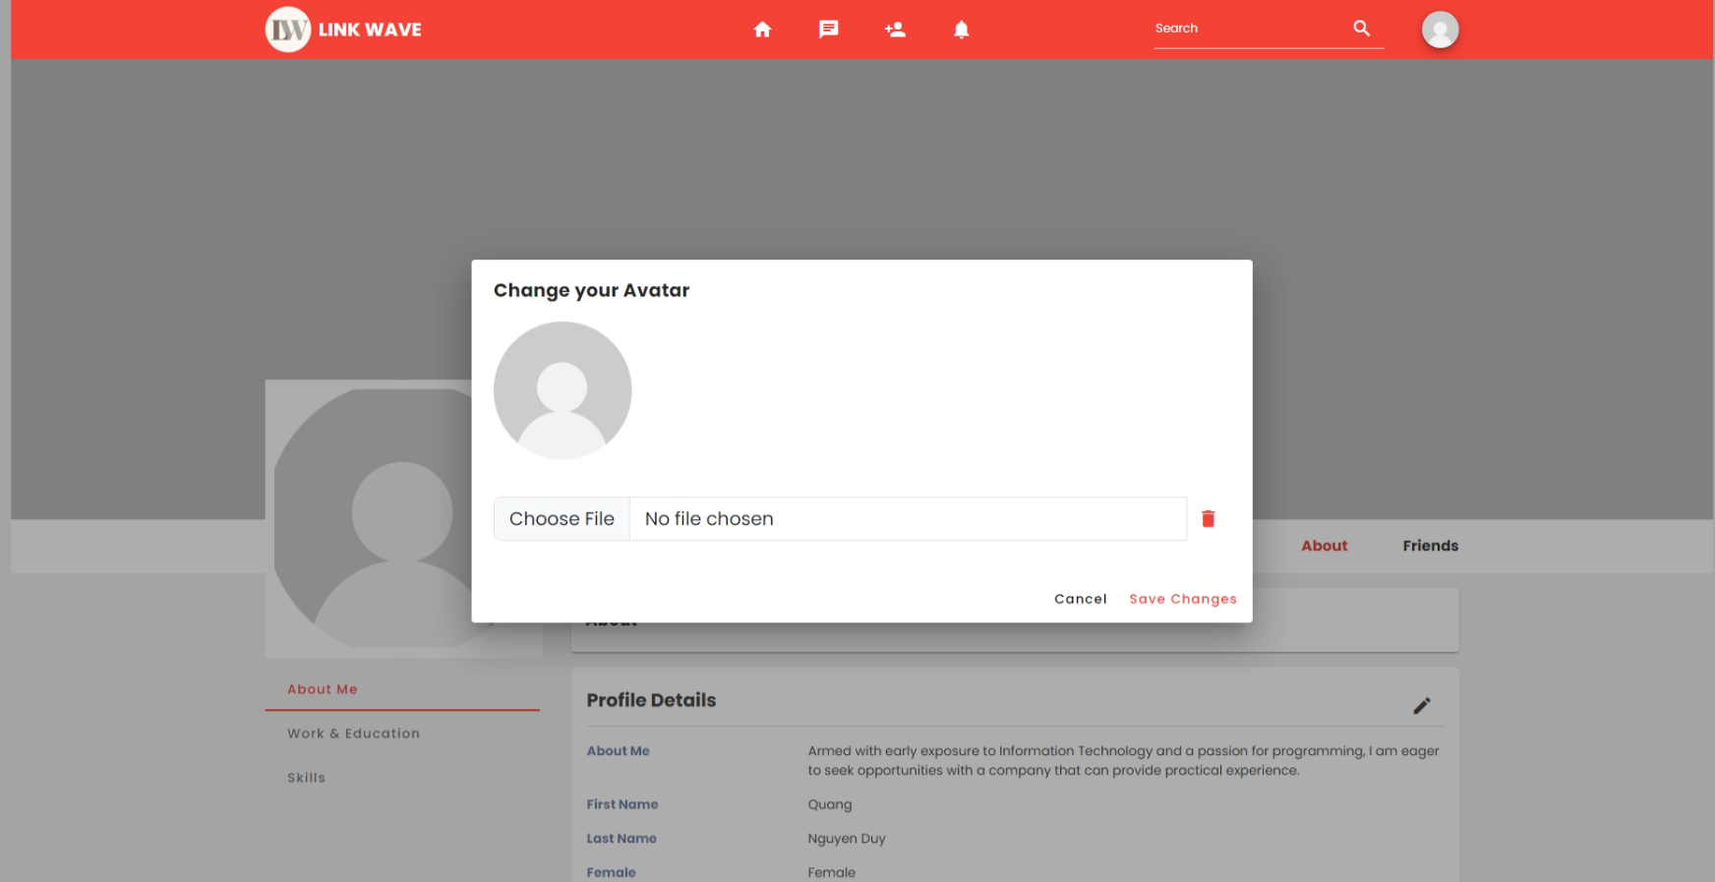

1. Choose new avatar

Next, the user chooses their avatar and the system will ask to crop the image to fit the frame.

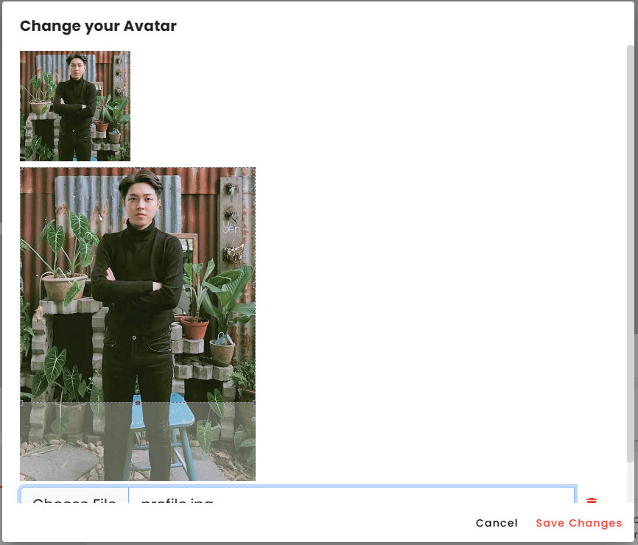

1. Choose new avatar and crop it

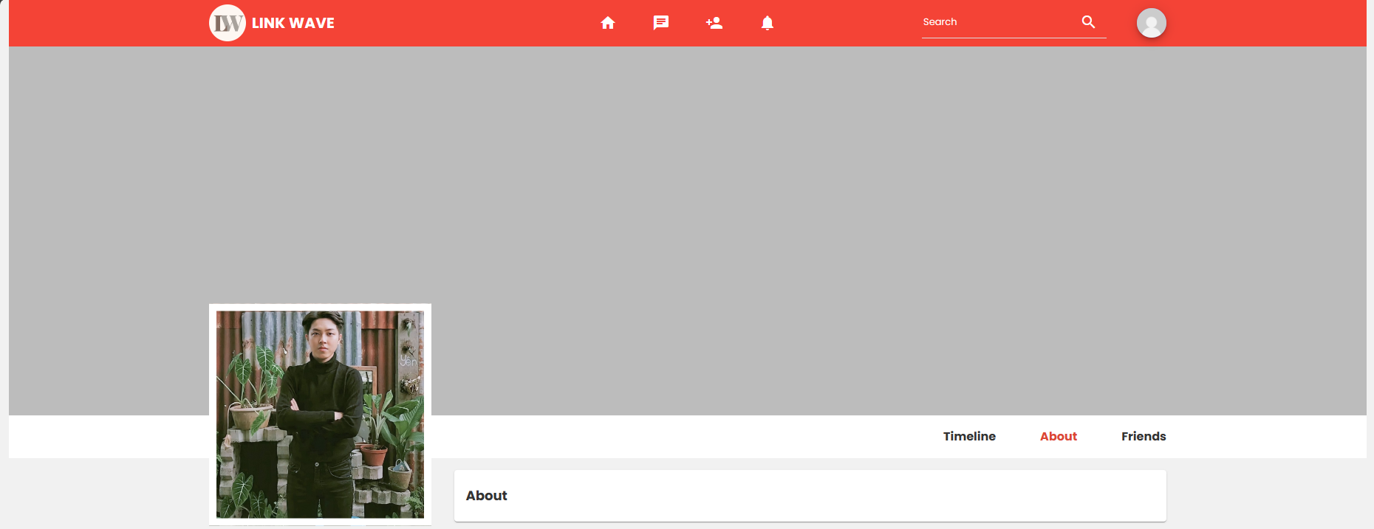

1. New avatar was saved

#### Change cover

When needing to change the cover image, the user points to the cover image and clicks "Change Picture".

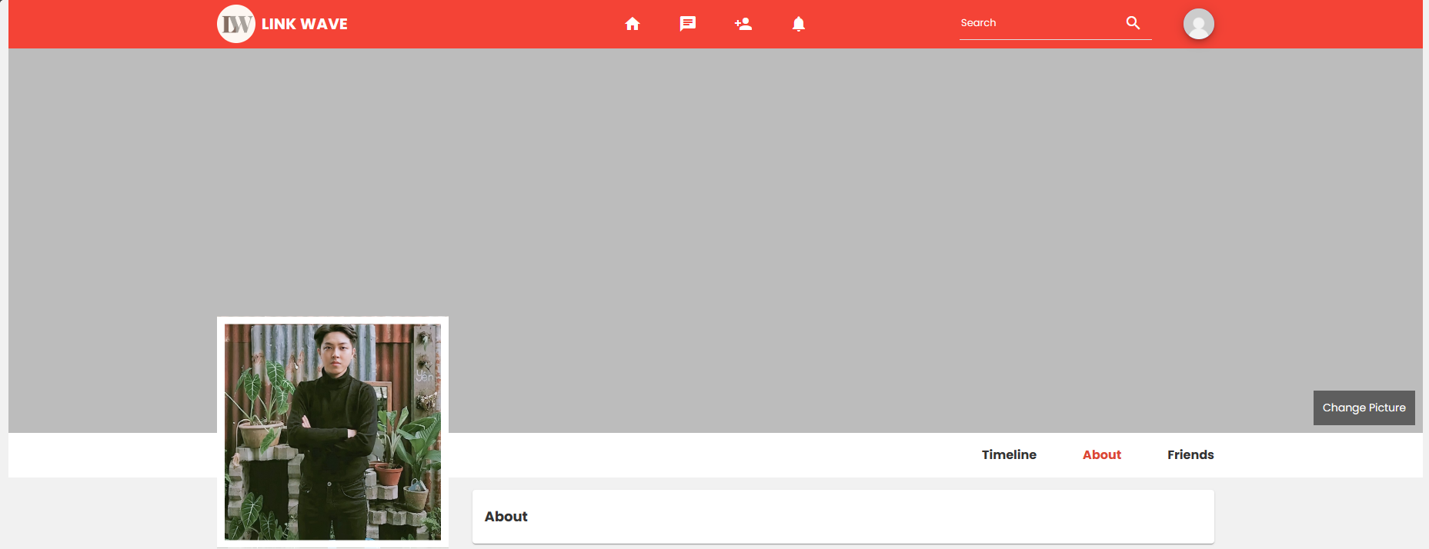

1. Hover to change cover

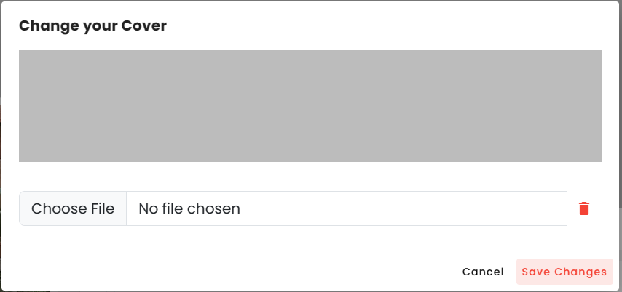

1. Choose new cover

Next, the user chooses their cover and the system will also ask to crop the image to fit the frame.

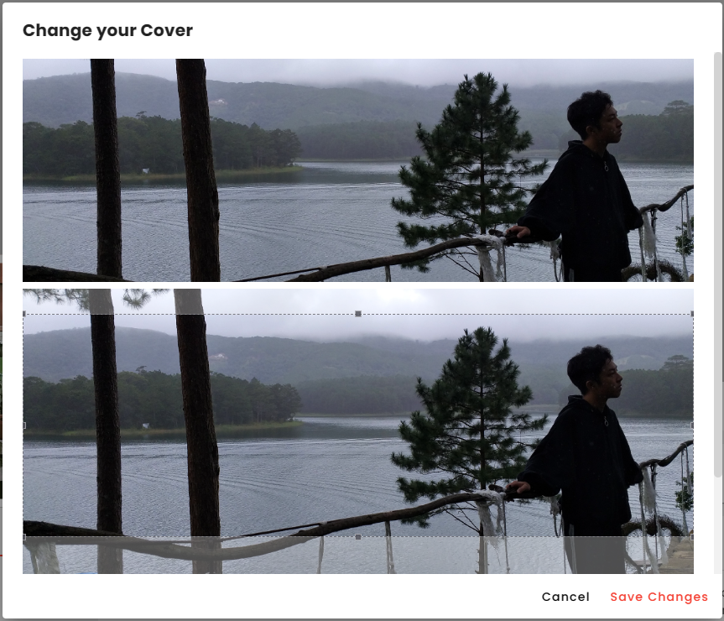

1. Choose new cover and crop it

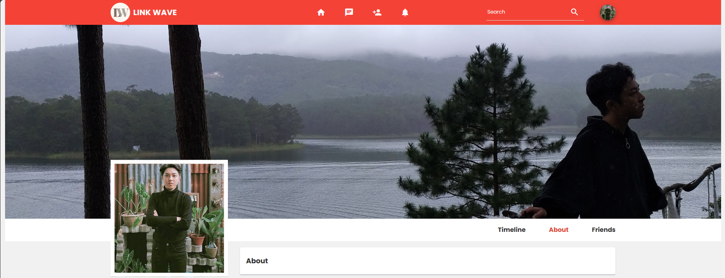

1. New cover was saved

#### Friend request

When users want to make friends, they click on the add friend icon on the navigation bar. This page displays friend suggestions and requests from other users.

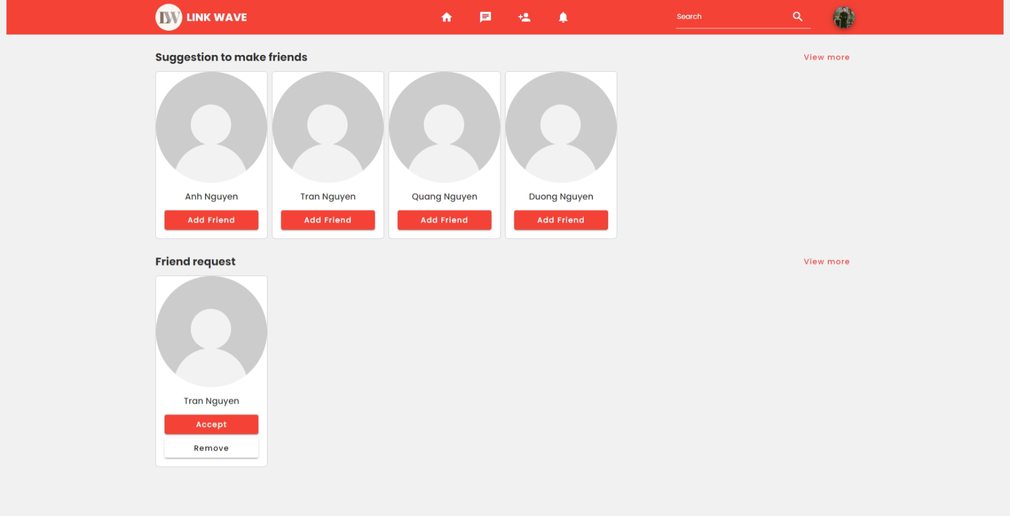

1. View friend

When the user clicks on "Add friend", the invitation will be sent to the recipient and the button will switch to "Recall" so the user can revoke the friend request.

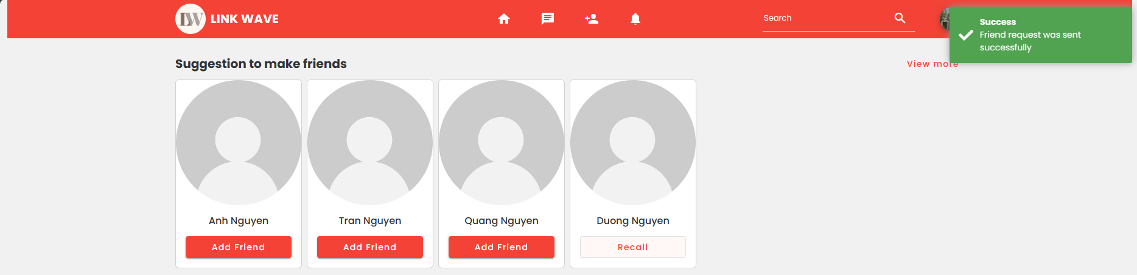

1. Send friend request

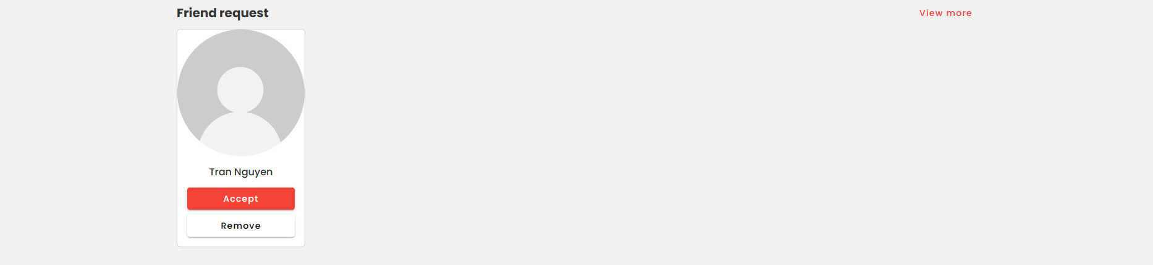

1. Receive friend request

After accepting the friend request, users can go to their friends list.

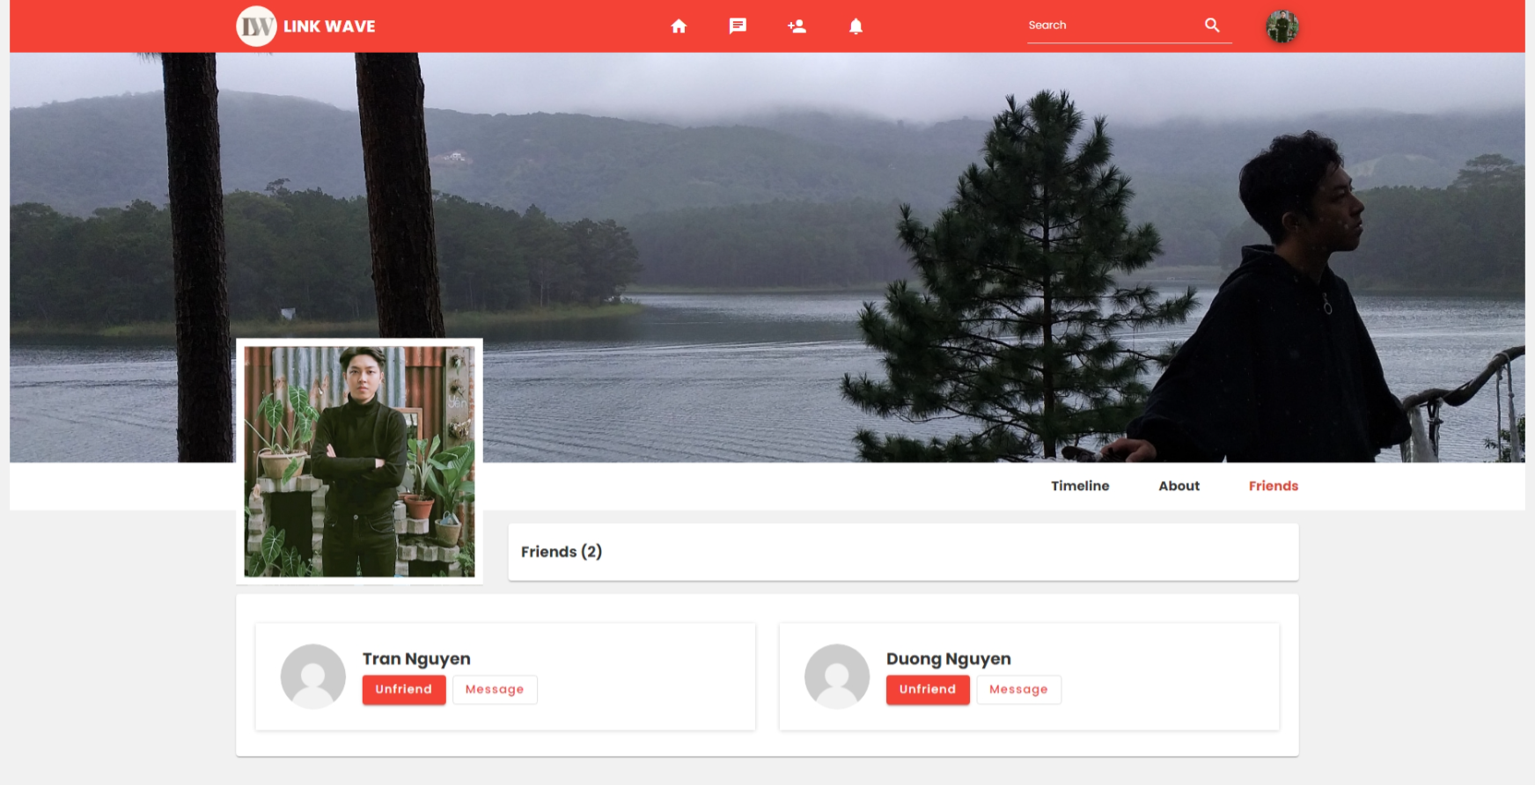

1. List friends of user

#### Chat message

To start a conversation, users can click the "Message" button in the friends list. At this point, the system will redirect to the chat page so they can chat with each other

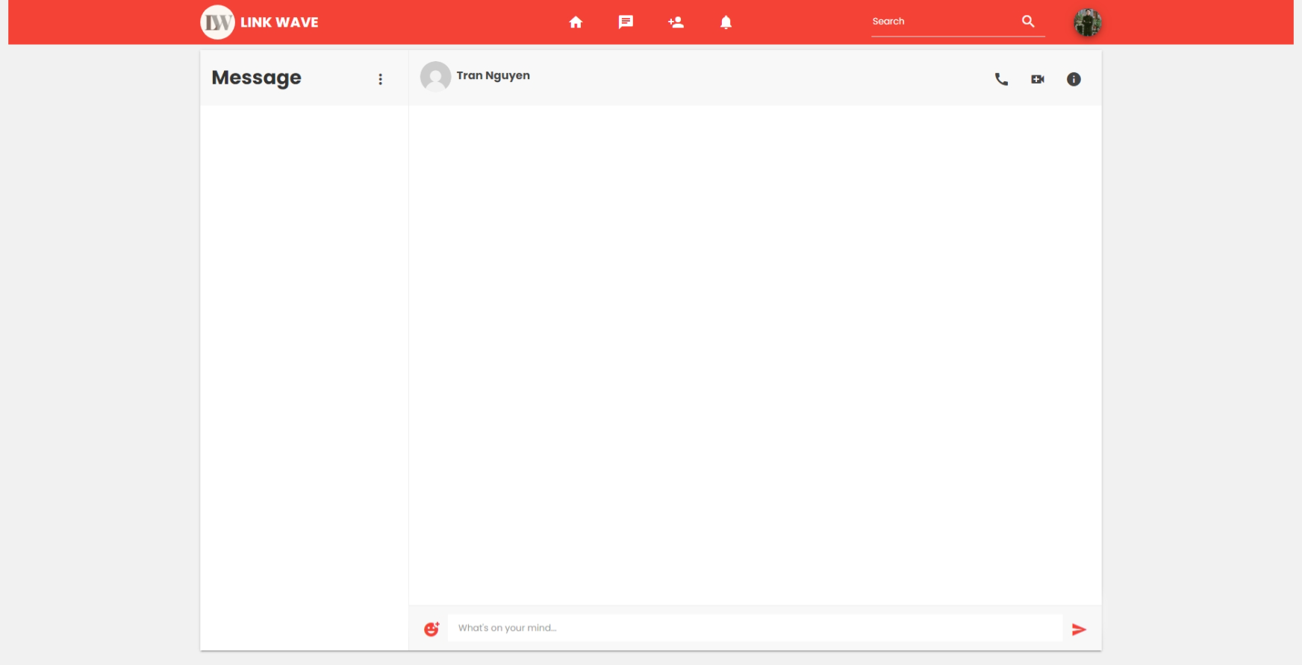

1. New conversation

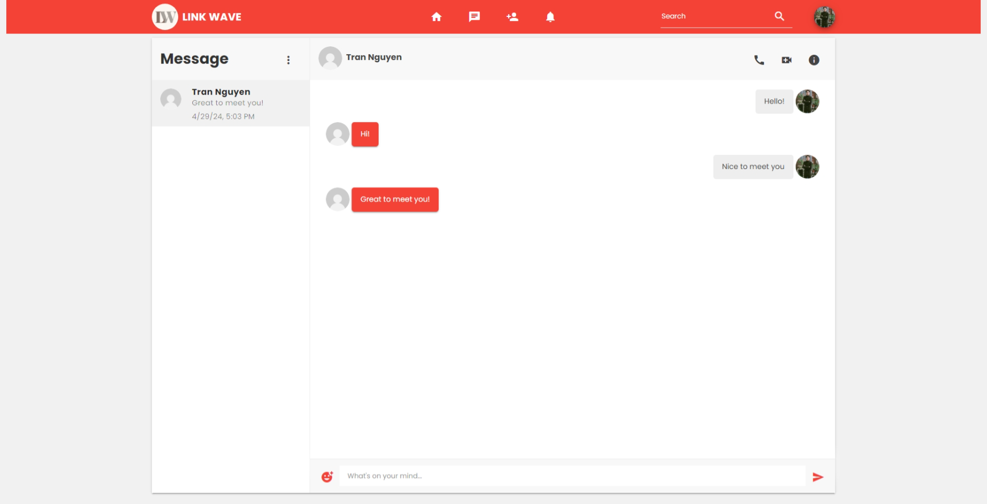

1. Message from current user

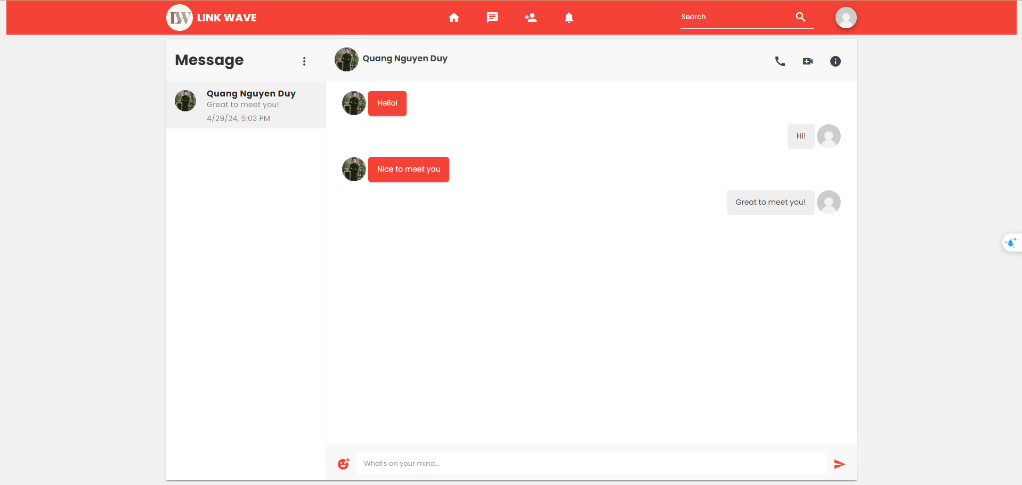

1. Message from friend of user

#### Notification

If users want to review notifications, they can click the bell icon on the navigation bar. This page will display all user notifications as well as unread notifications.

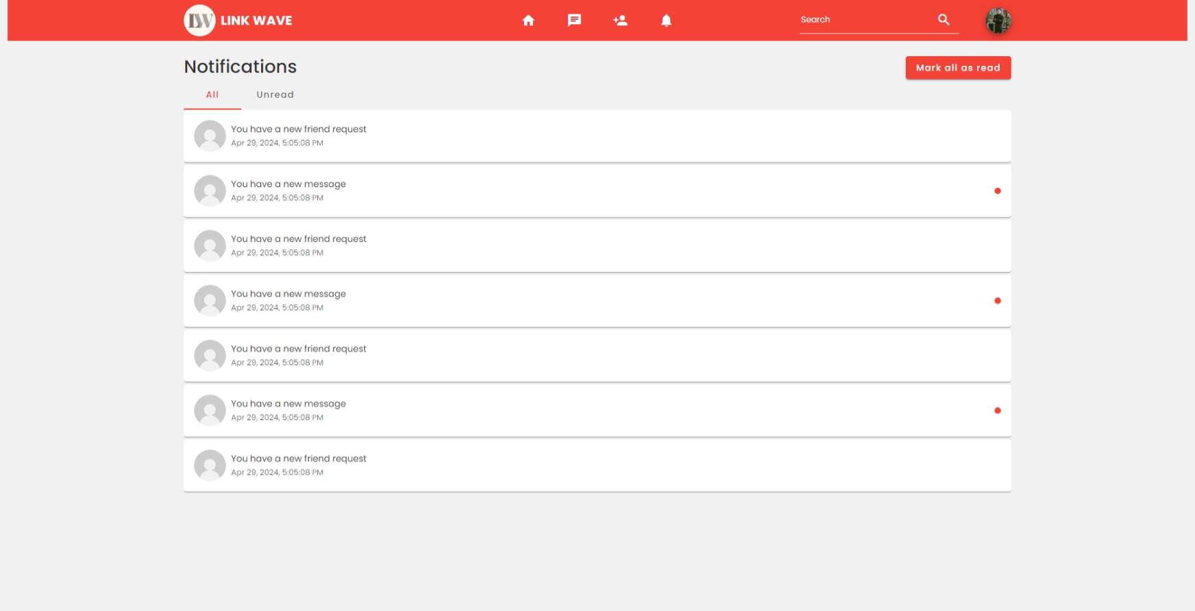

1. Notification

## Deploy Digital Ocean

### Create droplet

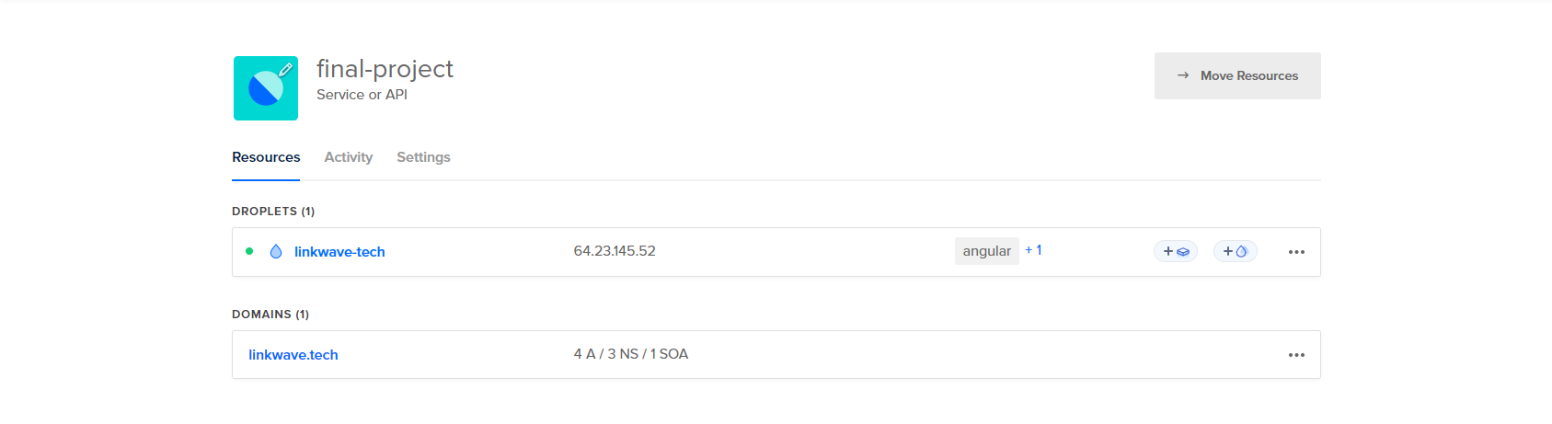

1. Create droplet and assign domain

### Config environment



1. Access to the server by using SSH



1. .env file

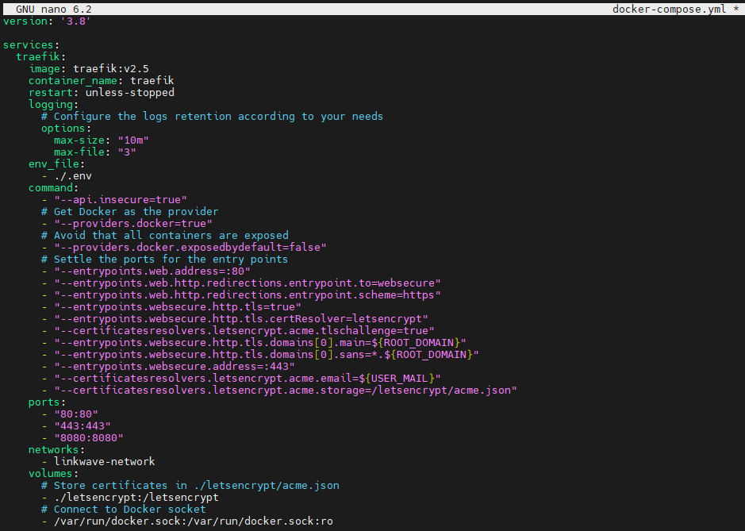

1. Docker compose file (traefik)

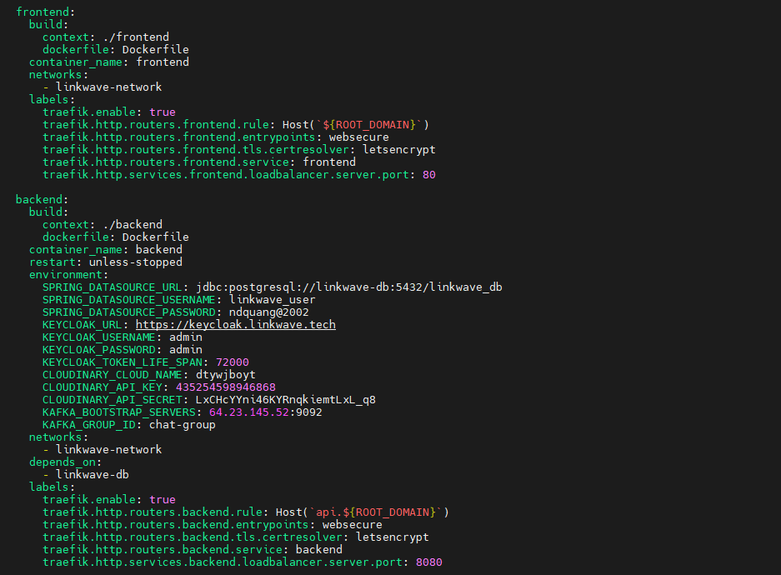

1. Docker compose file (frontend and backend)

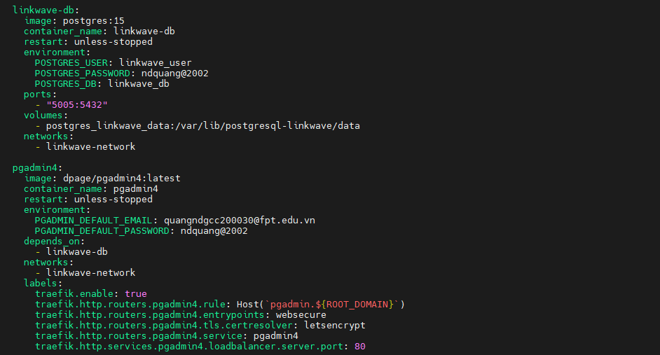

1. Docker compose file (database and pgadmin)

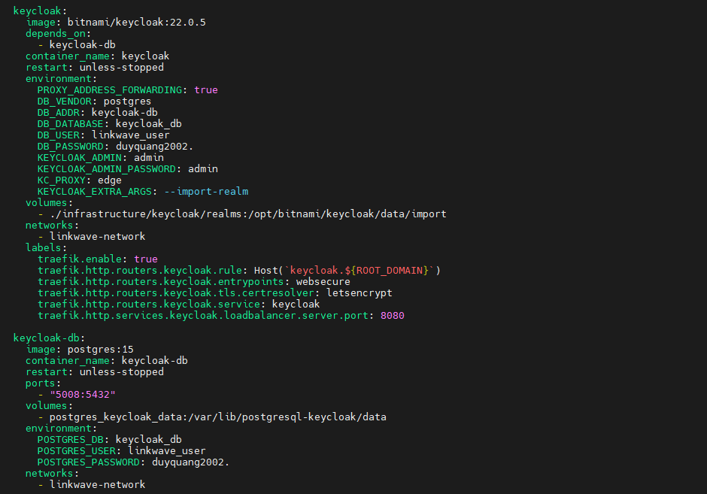

1. Docker compose file (keycloak and keycloak database)

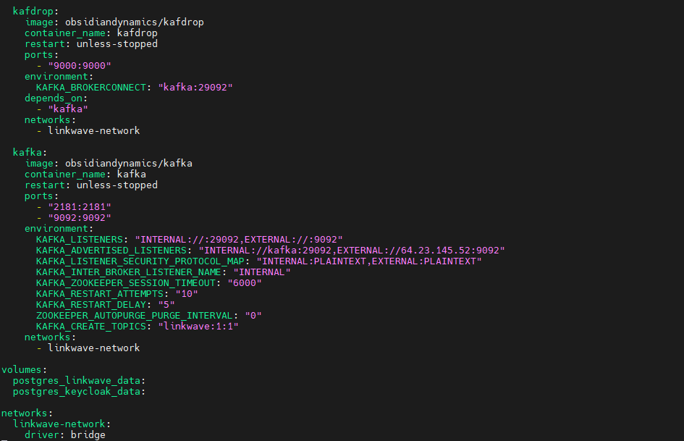

1. Docker compose file (kafka)

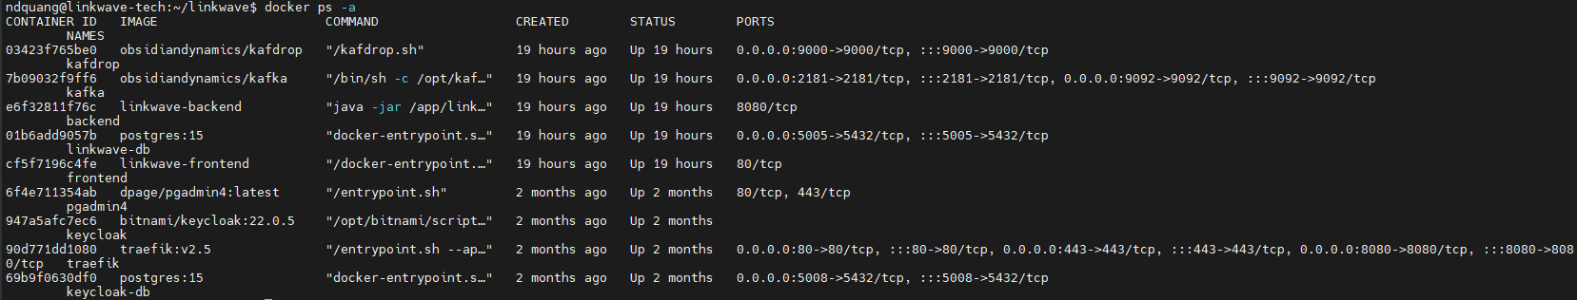

1. Docker logs

# TESTING AND EVALUATION

## Testing

### Functions

1. Test case

|  |  |  |  |  |  |  |
| --- | --- | --- | --- | --- | --- | --- |
| **No** | **Function** | **Action** | **Data Inputs** | **Expected Output** | **Actual Output** | **Result** |
|  | Login | Valid credentials | Email address: ndquang5802@gmail.com, Password: 12345678 | Successful login | Successful login | Pass |
|  | Invalid username | Email address: ndquang5, Password: 12345678 | Display error message: “Please enter a valid email address” | Display error message: “Please enter a valid email address” | Pass |
|  | Unconfirmed email | Email address: ndquang@gmail.com, Password: 12345678 | Show message system: “Invalid account. User probably hasn't verified email” | Show message system: “Please enter a valid email address |  |
|  | Register | Valid registration | First Name: Nguyen, Last Name: Duy Quang  Email address: quangndgcc200030@fpt.edu.vn, Password: 12345678, Confirm Password: 12345678 | Successful registration | Successful registration | Pass |
|  | Weak password | First Name: Nguyen, Last Name: Quang  Email address: ndquang5802@gmail.com, Password: pass123, Confirm Password: pass123 | Error message: "Please enter at least 8 characters." | Error message: "Please enter at least 8 characters." | Pass |
|  | Reset password | Valid email | Email: quangnguyen@gmail.com | Email sent with password reset instructions | Email sent with password reset instructions | Pass |
|  | Chat | Send message | Type message: "Hello, what your name? | Message sent successfully | Message sent successfully | Pass |
|  | Receive message |  | New message notification appears | New message notification appears | Pass |
|  | Friend request | Send request | Send request to Que Tran | Show system notifications “Friend request was sent successfully” | Show system notifications “Friend request was sent successfully” | Pass |
|  | Recall request | Recall sent request to Que Tran | Show system notifications “Friend request was deleted successfully” | Show system notifications “Friend request was deleted successfully” | Pass |
|  | Accept request | Accept friend request from Hung Dung | Show system notifications “Friend request was accepted successfully” | Show system notifications “Friend request was accepted successfully” | Pass |
|  | Remove friend | Remove Hung Dung from friend list | Show system notifications “Unfriended successfully” | Show system notifications “Unfriended successfully” | Pass |
|  | Manage profile | Update profile | Email: ndquang5802@gmail.com  First Name: Quang  Last Name: Nguyen  Gender: Male  Birthday: 08/05/2002  Address: Can Tho city  Phone number: 0916843367  Country: Vietnam  Hobbies: Coding | Profile updated successfully | Profile updated successfully | Pass |
|  |  | Upload avatar picture | Choose file: profile.jpg | Display success message “Update avatar successfully” | Display success message “Update avatar successfully” | Pass |
|  | Manage Work & Education | Add new work | Company Name: Harvard University  Position: Bachelor of Arts in Economics  Description: Completed coursework in microeconomics, macroeconomics, and econometrics.  Start Date: 09/01/2018  End Date: 05/15/2022  Location: Cambridge, Massachusetts | Display success message “Add work experience successfully” | Display success message “Add work experience successfully” | Pass |
|  |  | Update experience | Company Name: Harvard University  Position: Bachelor of Arts in Economics  Description: Completed coursework in information technology, including database management, software development, and network administration.  Start Date: 09/01/2018  End Date: 05/15/2022  Location: Cambridge, Massachusetts | Display success message “Update work experience successfully” | Display success message “Update work experience successfully” | Pass |
|  |  | Delete experience | Clicking delete job experience | Display success message “Delete work experience successfully” | Display success message “Delete work experience successfully” | Pass |
|  |  | Add new education | Company Name: University of Greenwich  Position: Bachelor of Science in Computer Science  Description: Studied computer programming, algorithms, and software engineering principles.  Start Date: 09/20/2020  End Date: 06/15/2024  Location: Greenwich, London, United Kingdom | Display success message “Add education experience successfully” | Display success message “Add education experience successfully” |  |
|  |  | Do not fill in as updating education | Company Name: “ ”  Position: Bachelor of Science in Computer Science  Description: Studied computer programming, algorithms, and software engineering principles.  Start Date: 09/20/2020  End Date: 06/15/2024  Location: Greenwich, London, United Kingdom | Display error message “Please fill in all fields” | Display error message “Please fill in all fields” | Pass |
|  | Create new post | Post text content | Type text post content | Post created successfully | Post created successfully | Pass |
|  | Post image content | Choose image: image.jpg | Image post created successfully | Image post created successfully | Pass |
|  | Post video content | Choose video: video.mp4 | Video post created successfully | Video post created successfully | Pass |
|  | Change password | Valid password change | Current password: 12345678, New password: quang0508, Confirm Password: quang0508 | Password changed successfully | Password changed successfully | Pass |
|  | Invalid current password | Current password: invalidpass, New password: newpass123, Confirm Password: newpass123 | Error message: "Incorrect current password" | Error message: "Incorrect current password" | Pass |
|  | Weak new password | Current password: pass123, New password: 1234, Confirm Password: 1234 | Error message: "New password must be at least 6 characters" | Error message: "New password must be at least 6 characters" | Pass |
|  | Password mismatch | Current password: pass123, New password: newpass123, Confirm Password: newpass456 | Error message: "Passwords do not match" | Error message: "Passwords do not match" | Pass |
|  | Manage notifications | Mark all as read | Clicking the “Mark all as read” button | All notifications marked as read | All notifications marked as read | Pass |
|  | View all notifications | Clicking the notification icon. | All notifications displayed | All notifications displayed | Pass |
|  | View all unread notifications | Clicking the “Unread” button | All unread notifications displayed | All unread notifications displayed | Pass |
|  |  | Remove a notification | Clicking the “Remove this notification” button | Display success message “Remove notification successfully” | Display success message “Remove notification successfully” | Pass |
|  |  | Mark notification as read | Clicking the “Mark as read” button | The notification will change to be read status | The notification will change to be read status | Pass |
|  | Search | Search for user | Search: "John" | User account matching query displayed | User account matching query displayed | Pass |
|  | Search for post | Type search query: "technology" | Posts containing "technology" displayed | Posts containing "technology" displayed | Pass |
|  | Search for skill | Type search query: "programming" | Skills related to "programming" displayed | Skills related to "programming" displayed | Pass |
|  | Log out | Log out | Click on logout button | User logged out successfully | User logged out successfully | Pass |

### Performance

Below is a performance test image of the website through Lighthouse



1. Analysis all performance

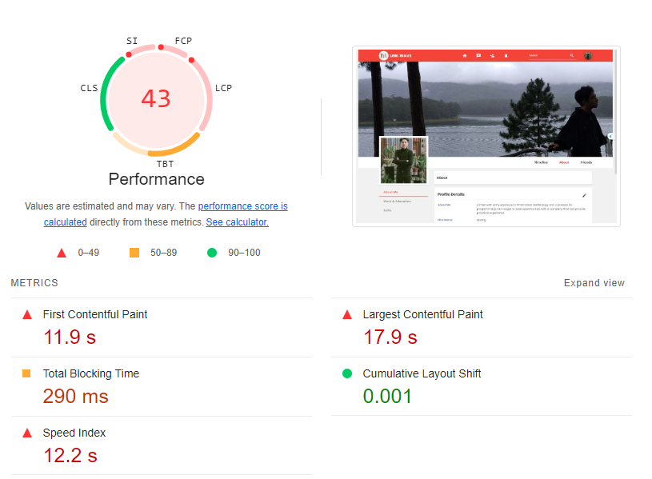

1. Testing performance

* Optimize images: Use modern, compressed formats like WebP.
* Minimize render-blocking resources: Inline critical CSS and defer non-critical JavaScript/CSS.
* Remove unused JavaScript/CSS: Use tools to identify and eliminate unnecessary code.
* Improve server response times: Optimize server or use a Content Delivery Network (CDN).

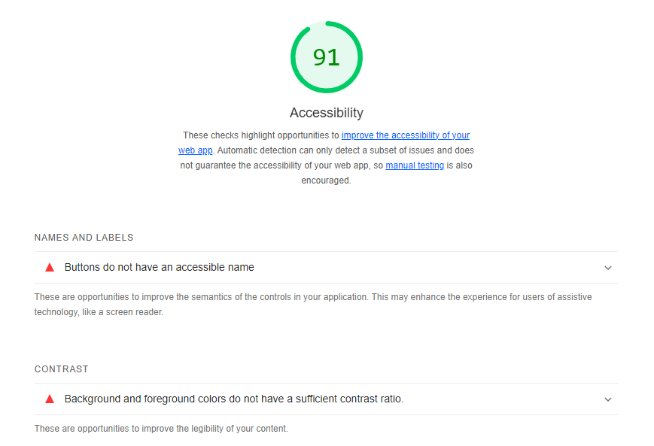

1. Testing accessibility

While the score is good, ensure all interactive elements are keyboard navigable and all images have alt text for screen readers. You can also manually check the site with assistive technology or consult WCAG guidelines for any further improvements.

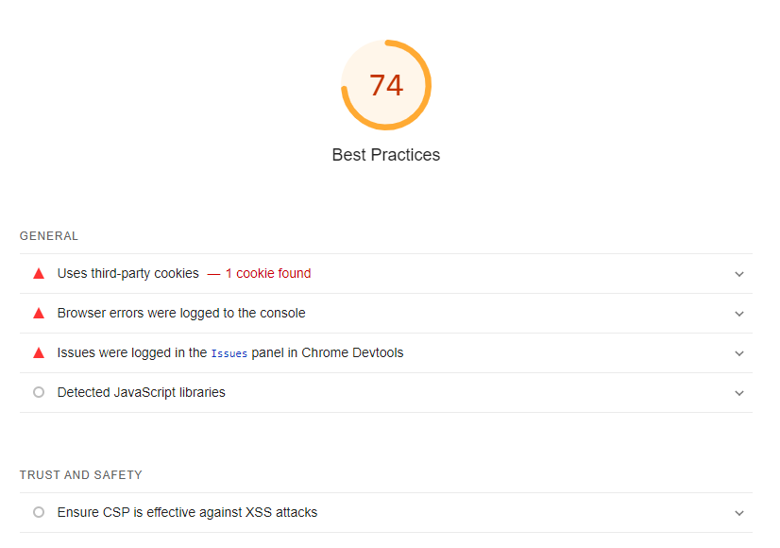

1. Testing best practice

* Enforce HTTPS to ensure data is encrypted in transit.
* Remove any deprecated APIs and replace them with modern alternatives.
* Ensure all external links use rel="noopener" to prevent security vulnerabilities.

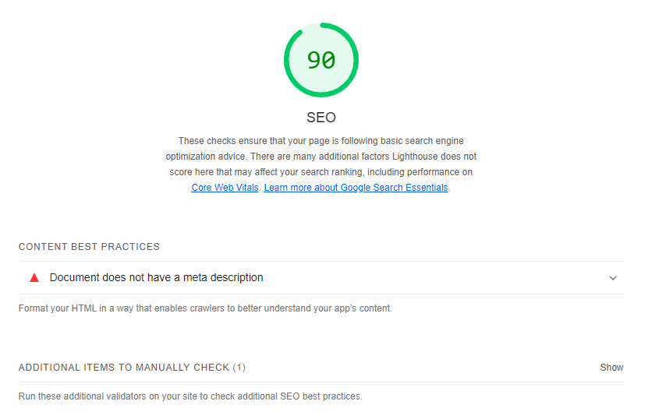

1. Testing SEO

Since this score is already high, look at the detailed recommendations from Lighthouse and address any small issues, such as meta tags or link texts that could be optimized further.

## Evaluation

### Self-evaluate

Based on my self-assessment, I find the user interface intuitive and user-friendly, with visually distinct icons and colors facilitating easy function input. The website adheres to security standards with HTTPS validation and employs encryption for user passwords. However, I recognize that there are vulnerabilities that need to be addressed before the site can be safely deployed for commercial use. In particular, certain areas are susceptible to exploitation by hackers.

Regarding performance, while the website is functional, its loading speed is subpar compared to contemporary standards. This impacts user experience and may deter potential users from engaging with the site efficiently.

To improve the website's security, I plan to implement additional layers of protection such as robust firewall systems, regular security audits, and intrusion detection mechanisms. Additionally, I will conduct thorough testing to identify and patch any existing vulnerabilities.

To enhance performance, I intend to optimize the website's code, compress images, and leverage caching techniques to reduce loading times. Furthermore, I will explore options for scalable hosting solutions to accommodate increased traffic without compromising speed.

By addressing these concerns, I aim to elevate the website to a level where it meets both security best practices and performance expectations for commercial deployment.

### Survey from users

The survey administered through Google Form involved 50 participants, encompassing 8 quantitative and 2 qualitative inquiries. Each question underwent a thorough evaluation to ascertain its depth and relevance. This report will provide a detailed analysis of each question and highlight the key takeaways from the survey. The survey results will provide valuable insights into the strengths and weaknesses of this social network project while allowing the developer to make informed decisions and prioritize improvements.

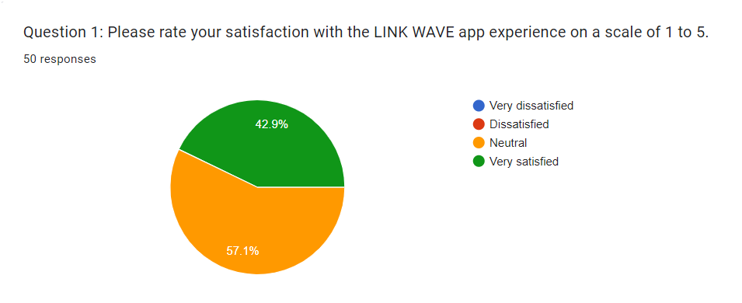

1. Question 1

The first question seeks to gauge participants' satisfaction levels with the LINK WAVE application, ranging from 1 (very dissatisfied) to 5 (very satisfied). Among the 50 responses, it's noteworthy that 42.9% expressed a neutral stance, while 57.1% indicated high satisfaction. This outcome suggests a predominantly positive sentiment towards the website throughout the user experience journey. However, particular attention should still be given to the neutral feedback from customers to enhance service quality and maximize user satisfaction.

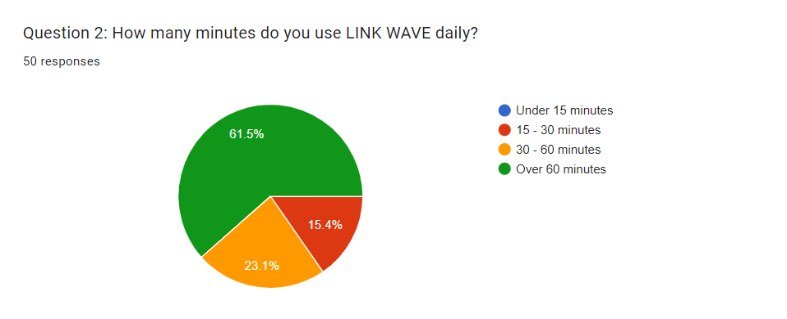

1. Question 2

The second question investigates participants' daily usage duration of the LINK WAVE app, segmented into four categories. Out of the 7 responses, the data indicates that 61.5% of users spend over 60 minutes daily, with smaller percentages allocating 15-30 minutes (15.4%) and 30-60 minutes (23.1%). The distribution of usage time suggests a considerable number of users invest significant time in the app, indicating its appeal and functionality. While a significant portion spends extensive time on the website, indicating its appeal and utility, the percentages allocated to 15-30 minutes and 30-60 minutes suggest areas for improvement. Implementing features such as user behavior tracking and personalized content recommendations could enhance engagement and attract more users in the future. This targeted approach ensures the platform remains relevant and adaptable to users' evolving needs and preferences.

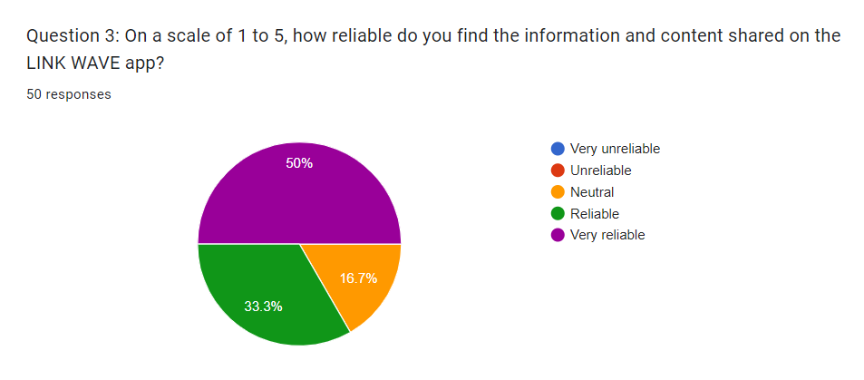

1. Question 3

The survey findings indicate a significant portion, 50%, of users perceive the content on the LINK WAVE app as "Very reliable," reflecting a considerable level of trust. Moreover, 33.3% of respondents find it "Reliable," reinforcing the perceived value of the platform's content. However, the presence of 16.7% neutrality underscores the need to enhance content credibility. Implementing solutions such as integrating AI-driven content verification tools like ChatGPT could establish more robust content validation mechanisms. Leveraging such technology, the LINK WAVE website could enhance its ability to detect and filter out inaccurate or misleading information, thereby improving overall information reliability and credibility.

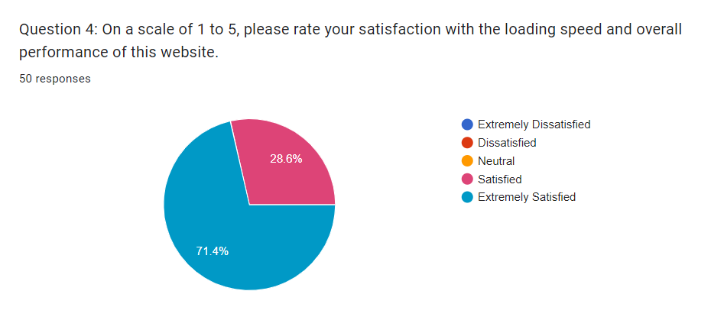

1. Question 4

The survey aimed to assess users' satisfaction with the loading speed and overall performance of the website on a scale from 1 to 5. Results show a significant 71.4% of respondents reported being "Extremely Satisfied," indicating a high level of contentment with the website's performance. Additionally, 28.6% expressed being "Satisfied." These findings suggest that the majority of users are pleased with the loading speed and overall performance. However, it's essential to continue monitoring and optimizing website performance to maintain user satisfaction.

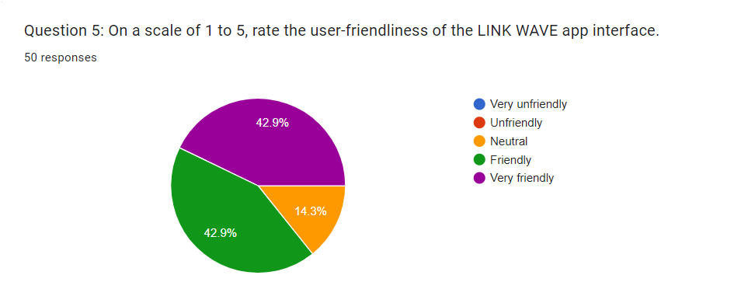

1. Question 5

The pie chart presents the results from a survey in which 50 respondents were asked to rate the user-friendliness of the LINK WAVE app interface on a scale from 1 to 5. The findings illustrate a positive reception, with a combined total of 85.8% of participants perceiving the app as user-friendly; this includes 42.9% who rated it as "Very friendly" and another 42.9% who considered it "Friendly". A modest 14.3% of users reported a neutral stance, neither satisfied nor dissatisfied with the interface. Significantly, there were no negative ratings; none of the users found the app "Unfriendly" or "Very unfriendly," suggesting a generally favorable view of the app’s user interface among the survey participants.



1. Question 6

The bar graph displays the feedback from 50 users concerning issues encountered while using a product or service. An overwhelming majority, 89.1% (41 respondents), reported no issues during their usage. A smaller fraction of users experienced problems, with 15.2% (7 respondents) indicating a lack of features and 6.5% (3 respondents) reporting difficulty in usage. Notably, there were no reported technical glitches among the respondents, highlighting a robust technical performance of the product or service in question. The data suggests that the user experience is largely positive, with only a few users encountering specific usability concerns or desiring additional features.

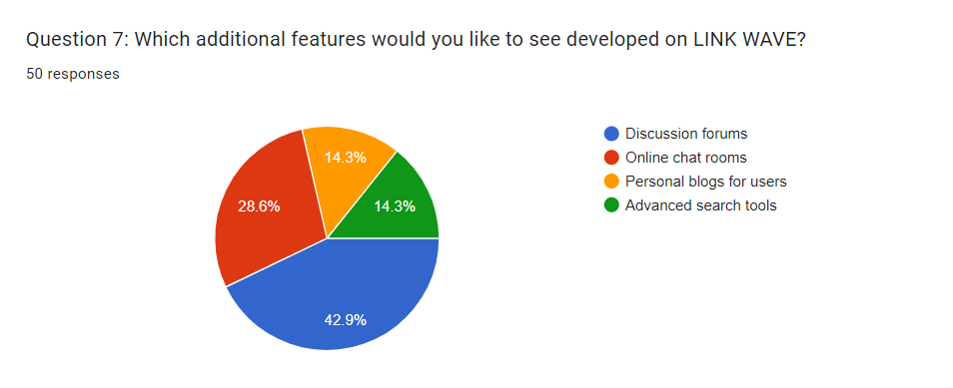

1. Question 7

The pie chart represents the preferences of 50 respondents regarding additional features they would like to see developed on LINK WAVE. The most requested feature is "Advanced search tools," accounting for 42.9% of the responses. "Discussion forums" are the next most popular, with 28.6% of users expressing interest in this feature. Both "Online chat rooms" and "Personal blogs for users" garnered an equal level of interest, each with 14.3% of respondents wanting these features. The data suggests that while there's a clear demand for enhanced search capabilities, there's also significant interest in more community-driven features such as forums and chat rooms, as well as personal expression through blogs.

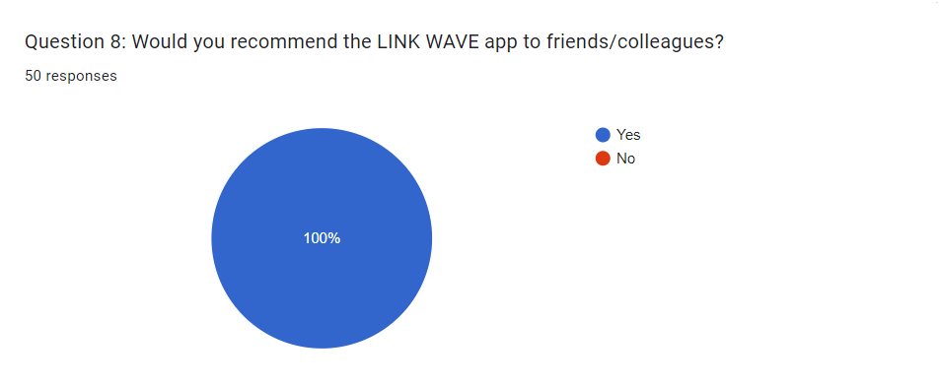

1. Question 8

The pie chart indicates a unanimous response from 50 participants to the question of whether they would recommend the LINK WAVE app to friends or colleagues. All respondents, which equates to 100%, answered "Yes," suggesting that the app has a highly favorable reputation among its users and they would endorse its use to others. This level of advocacy is indicative of strong user satisfaction and is a positive sign for the app's potential growth and popularity through word-of-mouth.

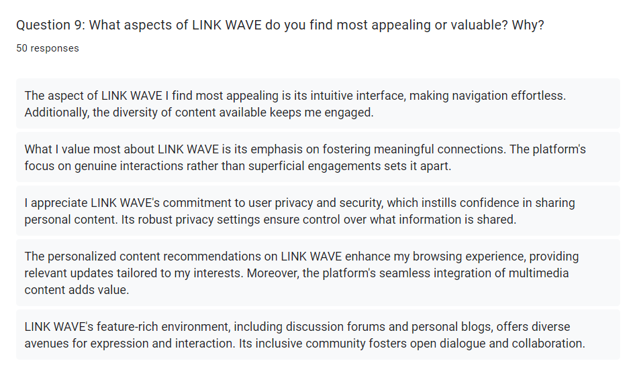

1. Question 9

The user feedback on LINK WAVE underscores a variety of features that resonate positively with its audience. Users find the platform's intuitive interface particularly appealing, citing effortless navigation and a rich diversity of content that maintains engagement. There's a strong appreciation for the emphasis on fostering genuine, meaningful connections over superficial interactions, setting LINK WAVE apart as a community-centric platform. Equally important to users is the commitment to privacy and security, instilling confidence to share personal content securely, thanks to comprehensive privacy settings. The tailored content recommendations are also highlighted, enhancing the browsing experience with relevant and personalized updates, while the seamless integration of multimedia content enriches the overall value. Additionally, the platform's inclusive environment, complete with discussion forums and personal blogs, is celebrated for offering varied avenues for user expression and interaction, fostering an open and collaborative community spirit.

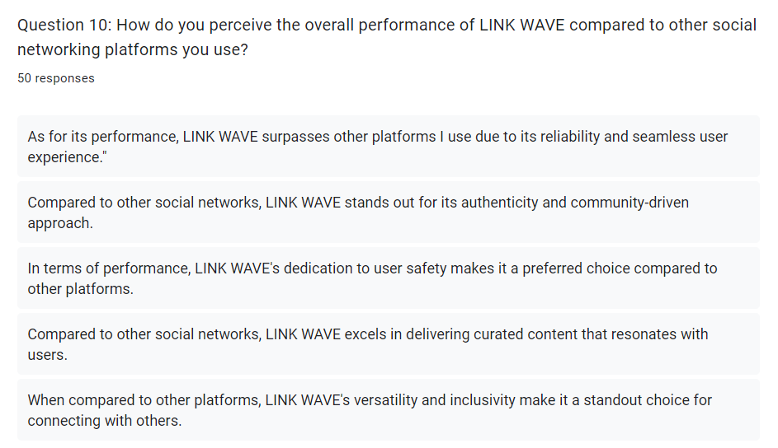

1. Question 10

Responses to the performance of LINK WAVE compared to other social networking platforms reveal a consensus that positions it favorably. Users perceive LINK WAVE to surpass other platforms due to its reliability and seamless experience. It is distinguished for its authenticity and a community-driven approach that seems to resonate well with the user base. LINK WAVE’s commitment to user safety is a significant factor in its preferred status among users, emphasizing a secure online environment. Additionally, the platform is praised for its ability to deliver curated content that aligns with user preferences, suggesting a personalized and engaging experience. Finally, its versatility and inclusivity are highlighted as key attributes, making LINK WAVE a comprehensive tool for social connection and interaction, further solidifying its place as a standout choice among social networks.

# CONCLUSIONS AND FUTUREWORK

## Conlusion

Throughout this final year project, I delved into a plethora of new technologies, significantly broadening my skill set. Notably, I gained proficiency in implementing authentication and authorization functionalities using Keycloak, thereby bolstering security measures. Moreover, I acquired the know-how to deploy websites efficiently through Docker and other cutting-edge technologies. These newfound skills not only enhance my current capabilities but also lay a robust foundation for future endeavors.

Undoubtedly, the journey wasn't devoid of challenges. Yet, each obstacle served as a catalyst for growth, pushing me to delve deeper and expand my expertise. Through relentless self-research and problem-solving, I overcame hurdles and propelled the project forward.

## Futurework

Moving forward, my focus will be on extending the usability of my system to mobile devices. Leveraging Flutter, I aim to craft features akin to those found in web applications, ensuring seamless access and functionality across various platforms. Additionally, optimizing algorithms will be paramount in enhancing user experience, prioritizing efficiency and responsiveness. By integrating these advancements, I strive to elevate the system's performance and accessibility, catering to the evolving needs of users and ensuring a superior experience across all devices.

# REFERENCES

Jamali, M. and Abolhassani, H. (2006) ‘Different aspects of social network analysis’, in. *2006 IEEE/WIC/ACM International Conference on Web Intelligence (WI 2006 Main Conference Proceedings)(WI’06)*, IEEE, pp. 66–72.

Rath, M. (2022) ‘Application and Impact of Social Network in Modern Society’, in *Research Anthology on Usage, Identity, and Impact of Social Media on Society and Culture*. IGI Global, pp. 637–650.

Zhang, J. and Philip, S.Y. (2018) ‘Cross-Platform Social Network Analysis.’

altexsoft, 2022. *The Good and the Bad of Flutter App Development.* [Online]   
Available at: https://www.altexsoft.com/blog/pros-and-cons-of-flutter-app-development/  
[Accessed 20 April 2024].

amazon, 2024. *What is Apache Kafka?.* [Online]   
Available at: https://aws.amazon.com/what-is/apache-kafka/  
[Accessed 20 April 2024].

amazon, 2024. *What is Java?.* [Online]   
Available at: https://aws.amazon.com/what-is/java/  
[Accessed 19 April 2024].

angular, 2024. *What is Angular?.* [Online]   
Available at: https://angular.io/guide/what-is-angular  
[Accessed 20 April 2024].

Badkar, A., 2023. *What is Dart Programming? Everything You Need to Get Started!.* [Online]   
Available at: https://www.simplilearn.com/what-is-dart-programming-article  
[Accessed 19 April 2024].

Bayoglu, M. B., 2023. *What Is Keycloak? What Is Behind Of The Keycloak? How Does Keycloak Work?.* [Online]   
Available at: https://bayoglubatuhan.medium.com/what-is-keycloak-what-is-behind-of-the-keycloak-how-does-keycloak-work-d1be308d3227  
[Accessed 20 April 2024].

Bhanderi, P., 2023. *Flutter’s Benefits and Drawbacks.* [Online]   
Available at: https://medium.com/@parthbhanderi01/flutters-benefits-and-drawbacks-b268c1fe0f7f  
[Accessed 20 April 2024].

Brown, L. C., 2020. The Evolution of Online Communities for Technology Enthusiasts.. *International Journal of Computer Science and Technology,* 9(2), pp. 78-91.

cloud, G., 2024. *PostgreSQL vs SQL Server: What are the key differences?.* [Online]   
Available at: https://cloud.google.com/learn/postgresql-vs-sql  
[Accessed 20 April 2024].

DRUMOND, C., 2024. *What is scrum and how to get started.* [Online]   
Available at: https://www.atlassian.com/agile/scrum  
[Accessed 18 April 2024].

Gillis, A. S., 2022. *DigitalOcean.* [Online]   
Available at: https://www.techtarget.com/searchcloudcomputing/definition/DigitalOcean  
[Accessed 20 April 2024].

java, 2024. *What is Java technology and why do I need it?.* [Online]   
Available at: https://www.java.com/en/download/help/whatis_java.html  
[Accessed 19 April 2024].

javatpoint, 2021. *Cloudinary.* [Online]   
Available at: https://www.javatpoint.com/cloudinary  
[Accessed 28 April 2024].

Jayeshwarke, 2023. *Getting Started with Spring Boot: Advantages, Disadvantages, and Use Cases.* [Online]   
Available at: https://medium.com/@jayeshwarke011/getting-started-with-spring-boot-advantages-disadvantages-and-use-cases-497b0f04fb86#:~:text=In%20conclusion%2C%20Spring%20Boot%20simplifies,and%20customization%20can%20be%20challenging.  
[Accessed 20 April 2024].

Johnson, M. S., 2018. Building Successful Online Communities for Technology Experts.. *Technology and Innovation,* 15(2), pp. 73-88.

Josh, 2024. *Native vs Cross-Platform: Navigating Social Media App Development.* [Online]   
Available at: https://www.developers.dev/tech-talk/social-media-app-development-native-vs-cross-platform.html  
[Accessed 18 April 2024].

Nek, D., 2024. *What is Traefik? How it Works, Features, Functions, and Benefits Explained.* [Online]   
Available at: https://webhostinggeeks.com/blog/traefik-features-functions-benefits/  
[Accessed 28 April 2024].

papertrail, 2024. *What Is DigitalOcean?.* [Online]   
Available at: https://www.papertrail.com/solution/guides/digitalocean/  
[Accessed 20 April 2024].

Peterson, R., 2024. *What is PostgreSQL? Introduction, Advantages & Disadvantages.* [Online]   
Available at: https://www.guru99.com/introduction-postgresql.html  
[Accessed 20 April 2024].

Rafalski, K., 2023. *Pros and Cons of Java Development in 2023.* [Online]   
Available at: https://www.netguru.com/blog/java-pros-and-cons#:~:text=Java%20is%20a%20versatile%20and,costs%2C%20and%20GUI%20development%20difficulties.  
[Accessed 19 April 2023].

Siddharth, 2021. *Angular: Pros and Cons.* [Online]   
Available at: https://dev.to/siddharthshyniben/angular-pros-and-cons-m9l  
[Accessed 20 April 2024].

Singh, R., Kumar, D. & Sagar, B. B., 2019. *Analytical Study of Agile Methodology in Information Technology Sector.* Mathura, India, IEEE.

Smith, J. A., 2021. Social Networking and Professional Development: The Role of Technology Experts.. *Journal of Technology Advancements,* 12(3), pp. 45-58.

typescriptlang, 2024. *TypeScript for JavaScript Programmers.* [Online]   
Available at: https://www.typescriptlang.org/docs/handbook/typescript-in-5-minutes.html  
[Accessed 19 April 2024].

Williams, R. D., 2019. Networking in the Digital Age: Strategies for Technology Professionals.. *Journal of Information Technology Networking,* 7(4), pp. 121-136.

Zaitsev, P., 2023. *What is TypeScript? Benefits of TypeScript and Disadvantages.* [Online]   
Available at: https://itjet.io/blog/what-is-typescript  
[Accessed 19 April 2024].

Zola, A., 2022. *Bootstrap.* [Online]   
Available at: https://www.techtarget.com/whatis/definition/bootstrap  
[Accessed 20 April 2024].

# APPENDIX

* **Source code:**

|  |  |
| --- | --- |
| Front end | <https://github.com/MyPersonalApplication/linkwave-website> |
| Back end | <https://github.com/MyPersonalApplication/linkwave> |

* **Link demo:** <https://linkwave.tech/>
* **Account test:**

|  |  |  |
| --- | --- | --- |
| **Roles** | **Email** | **Password** |
| Admin | [admin@linkwave.com](mailto:admin@linkwave.com) | Admin@2024 |
| User | [ndquang5802@gmail.com](mailto:ndquang5802@gmail.com) | 12345678 |